**Practical 4**

**Aim:** Demonstrate the Dynamic routing configuration using RIP and OSPF protocol using cisco packet tracer

**Theory:**

**Dynamic routing:**

* Itis a networking technique that provides optimal data routing. Unlike static routing, dynamic routing enables routers to select paths according to real-time logical network layout changes.
* Dynamic routing uses multiple algorithms and protocols. The most popular are Routing Information Protocol (RIP) and Open Shortest Path First (OSPF).
* Dynamic routing protocols allow routers to share information about the network with other routers to allow them to select the best path to reach a destination.
* RIP:
  1. Routing Information Protocol version 2 (RIPv2) is an old routing protocol.
  2. RIPv2 suffers from scalability issues due to a relatively low maximum hop count of 15 routing devices.
* OSPF:

1. OSPF is the dynamic routing protocol used in large to very large IP networks.
2. The protocol uses a link-state database and link-state advertisements to map the network topology.

* Advantages of Dynamic Routing:
  1. Allows the exchange of routing information whenever the network experiences a change in topology.
  2. Since the routes do not have to be configured manually, there is less administrative overhead.
  3. Less error-prone than static routing.
  4. Allows scalability since there is less administrative overhead involved.

**Configuration Using RIPv2:**

**Topology:**

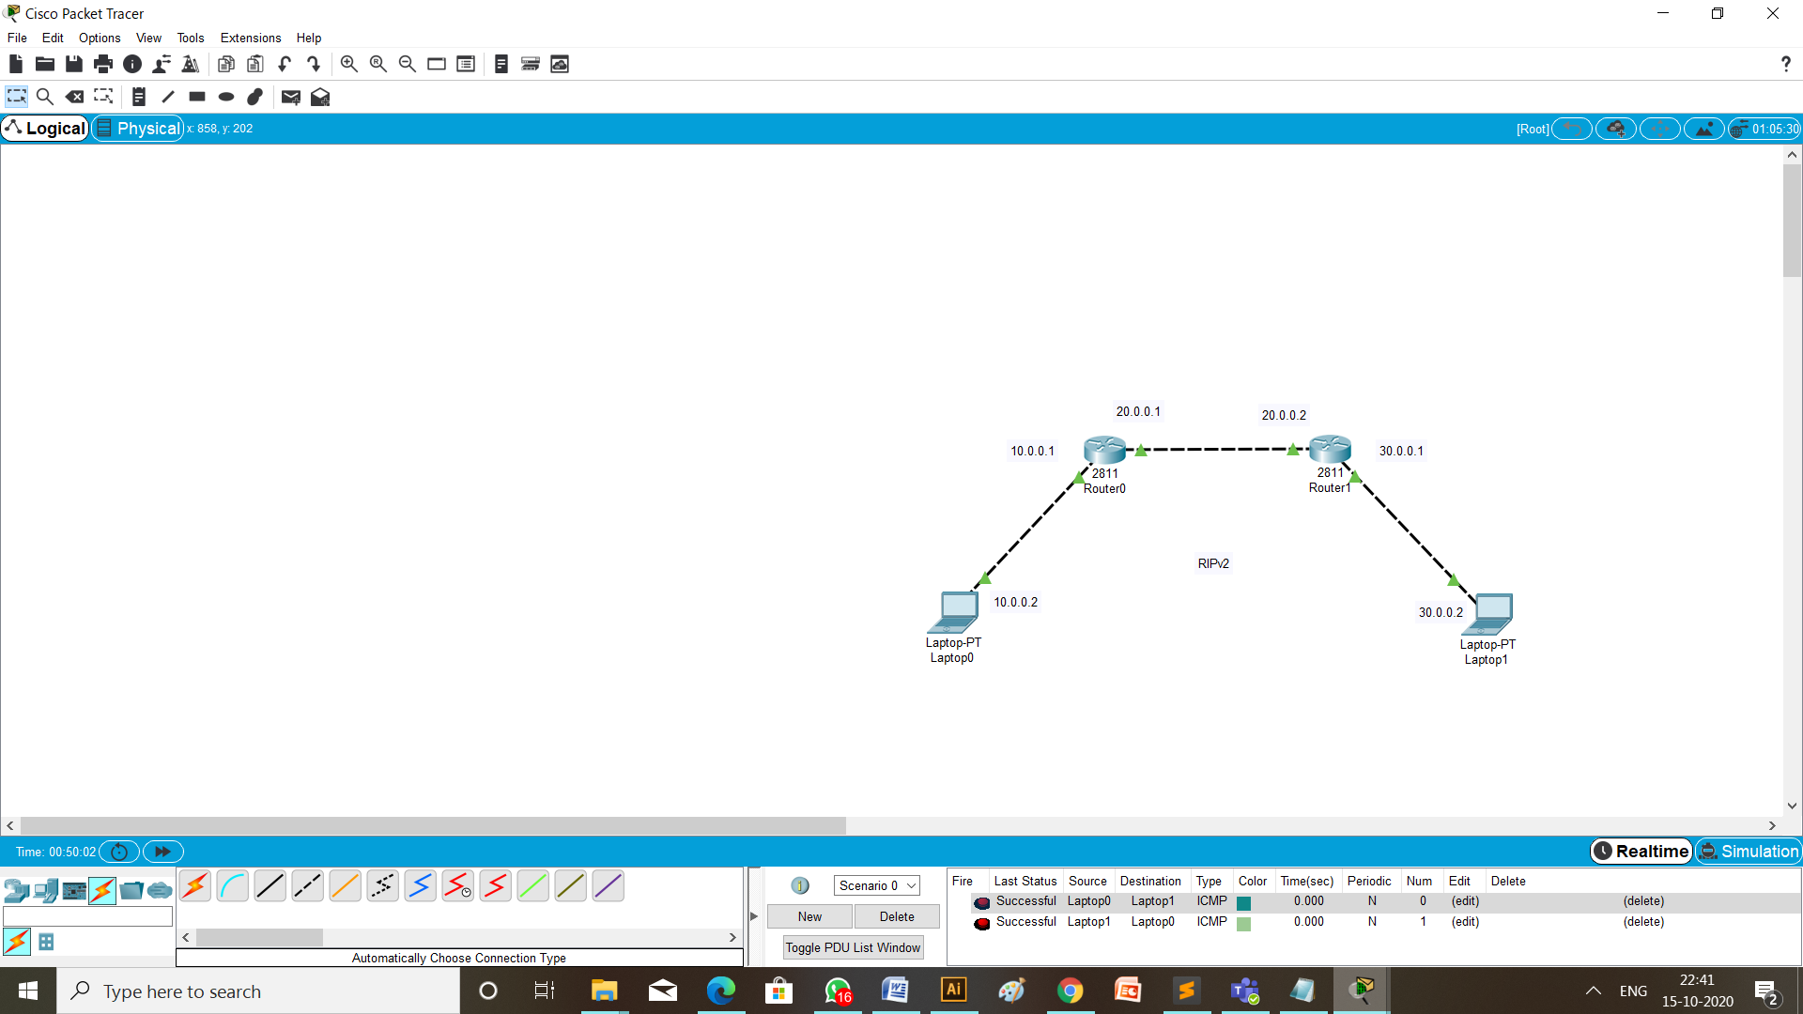

**Steps of Configurations:**

* First of all to create a topology, click on the device and drop on workplace and connect all the devices with the necessary cables.
* Then configure all the router using CLI and give the ip address as mention in the topology diagram.

1. Router 1: fa0/0 10.0.0.1

fa0/1 20.0.0.1

1. Router 2: fa0/0 20.0.0.2

fa0/1 30.0.0.1

* Provide ip address and default gateway to the laptops.
  1. Laptop 1: ip address is 10.0.0.2

default gateway is 10.0.0.1

* 1. Laptop 2: ip address is 30.0.0.2

default gateway is 30.0.0.1

* Configuration of RIPv2 on router 0 and router 1 are respectively,

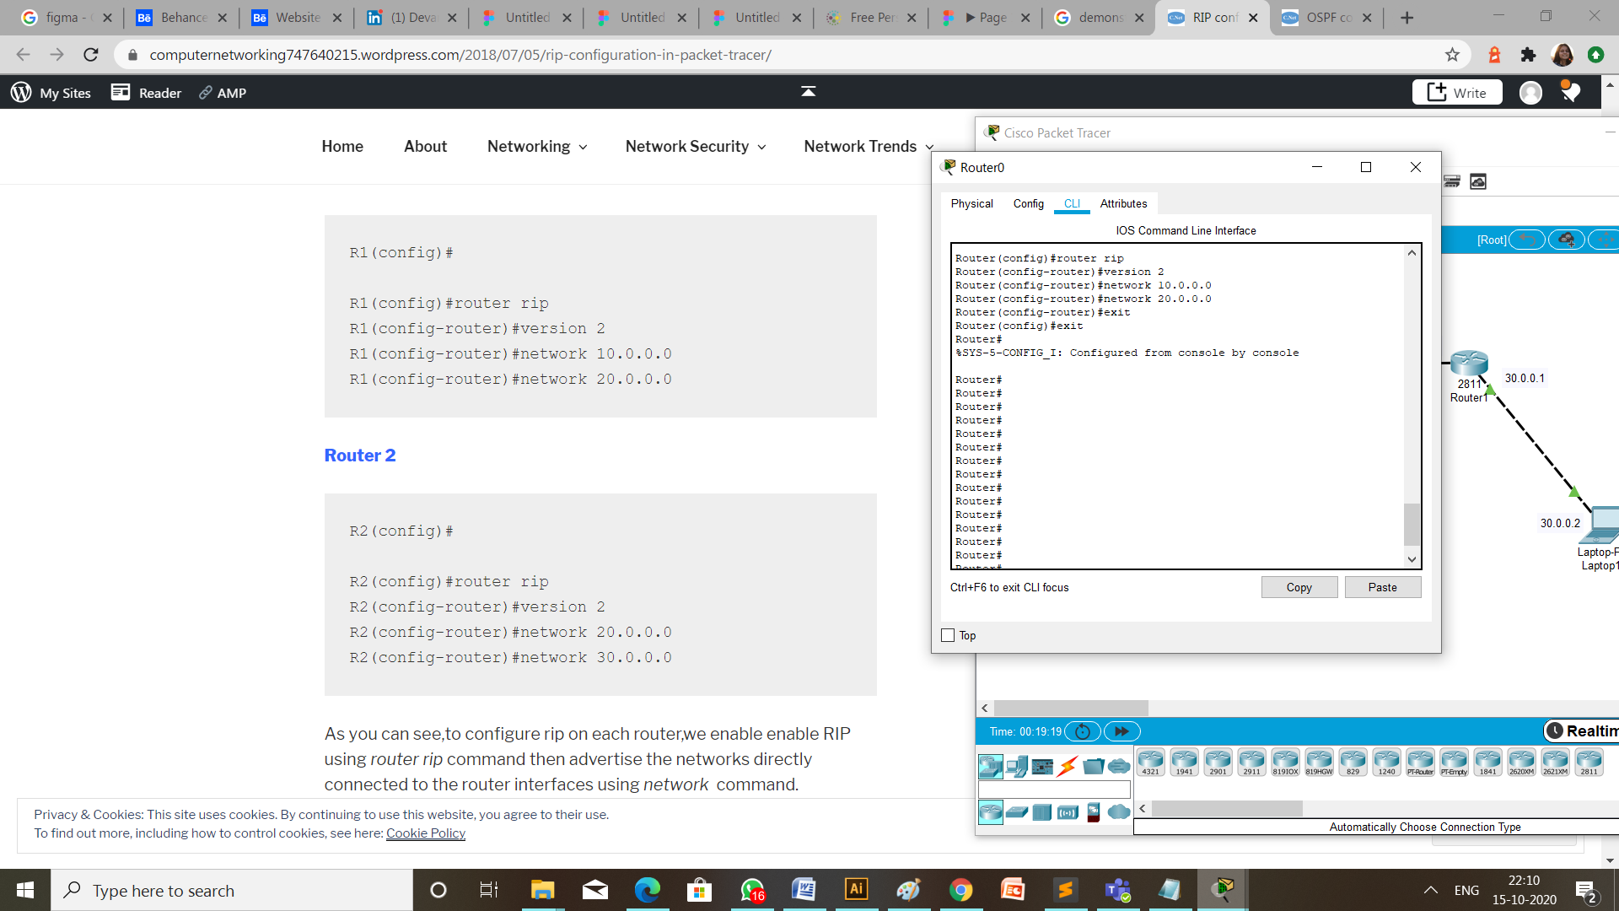

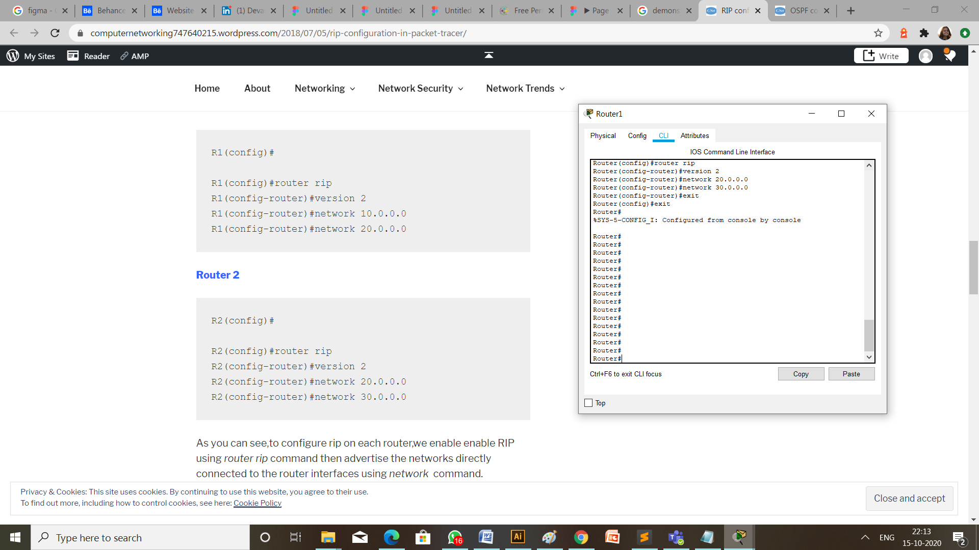

* Verify RIP configuration.

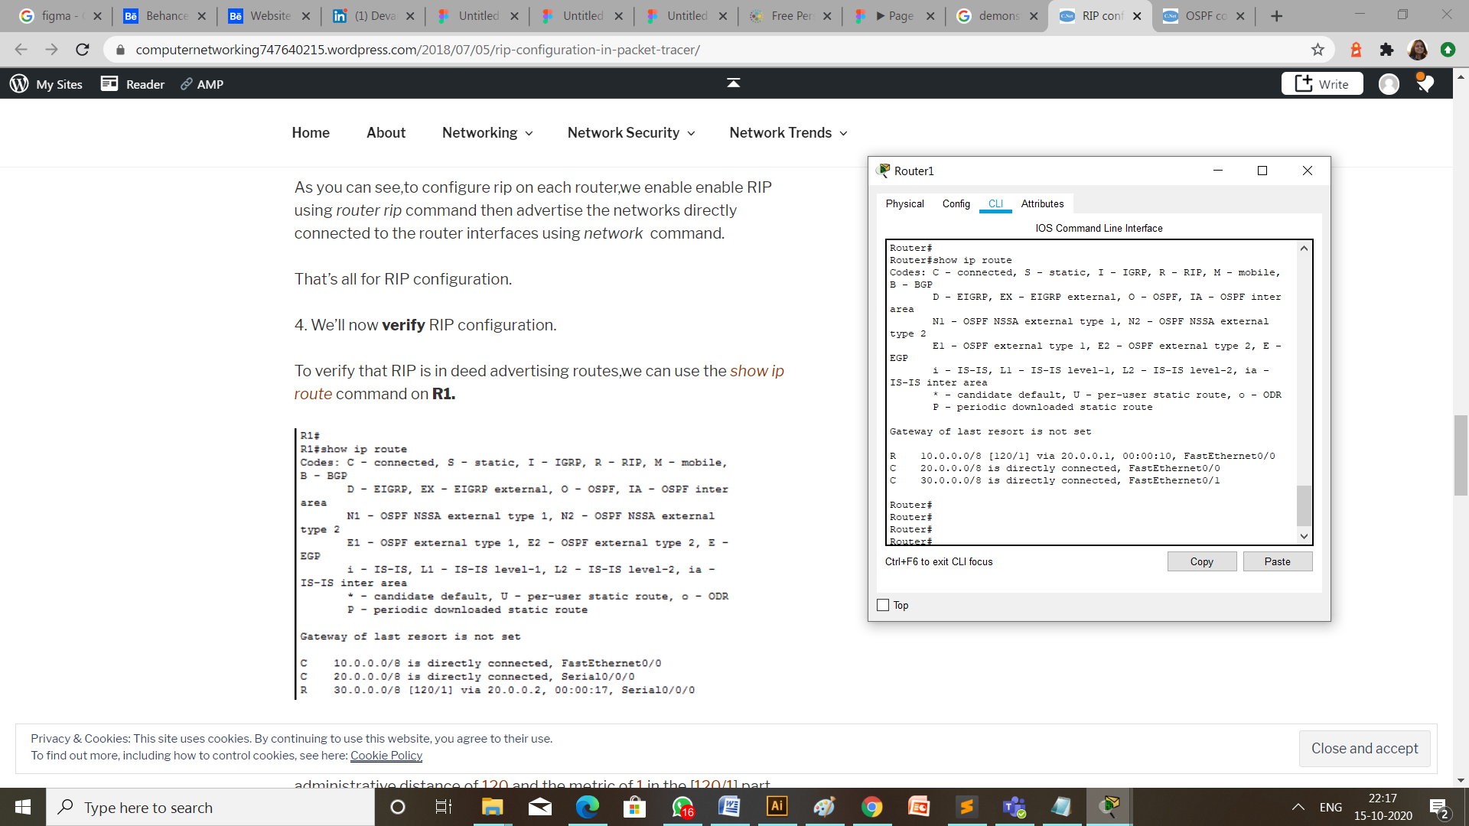

**Checking Network Topology:**

1. Message passing:

To check the connections are working properly or not drop one package on a Laptop 0 and receive it from the Laptop 1.



1. Using ping:

Write a command ping 10.0.0.2 (ip address of the destination Laptop) from the command prompt of Laptop having ip address 30.0.0.2 (the source Laptop).

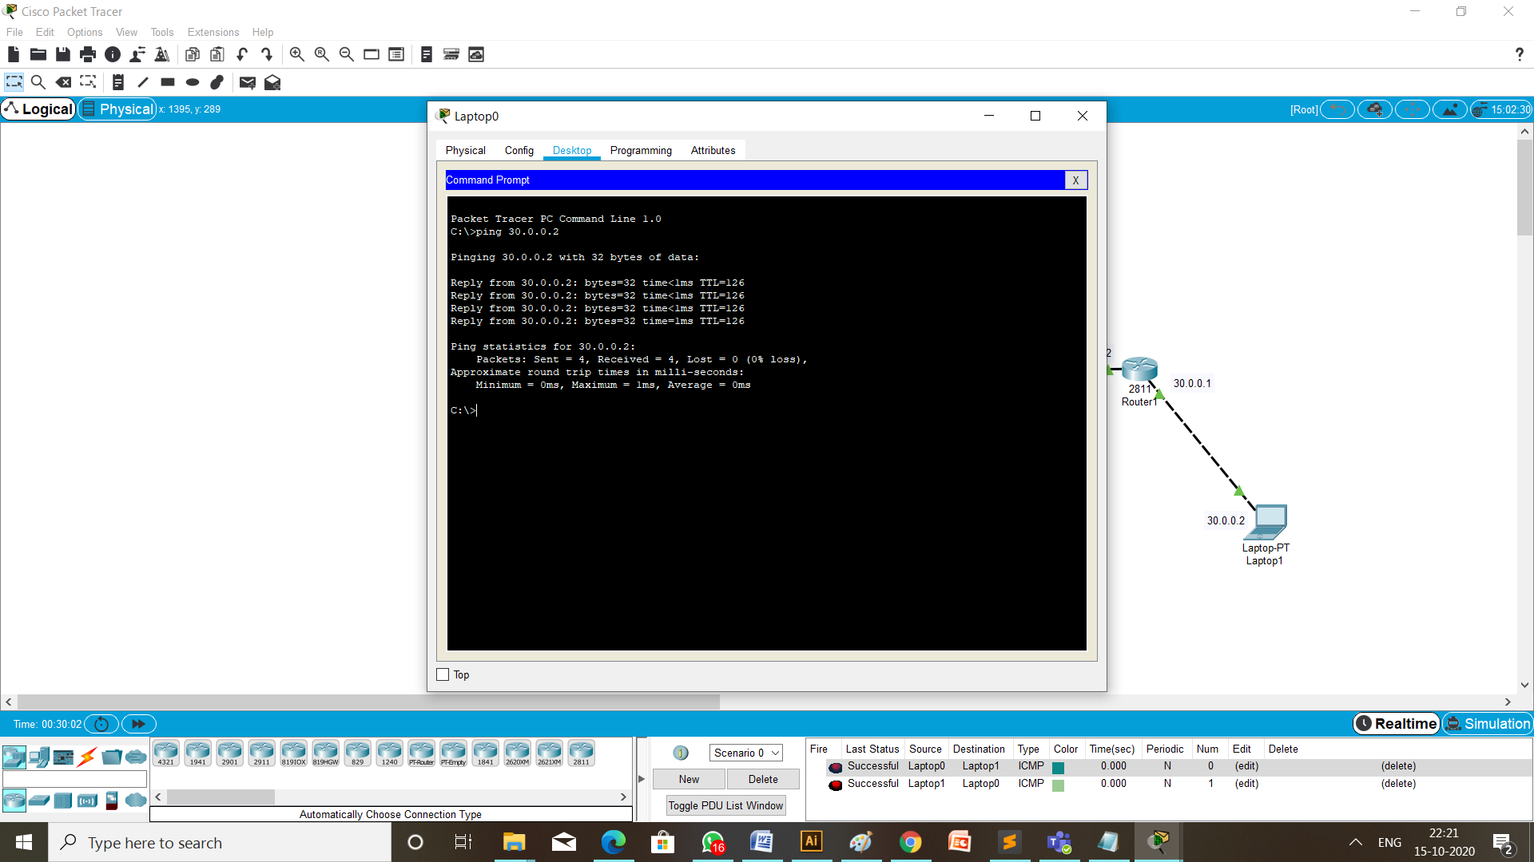

**Configuration Using RIPv2:**

**Topology:**

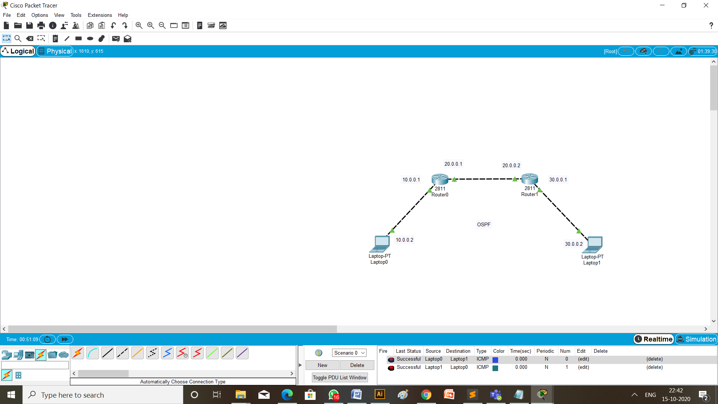

**Steps of Configurations:**

* Configuration of OSPF on router 0 and router 1 are respectively,

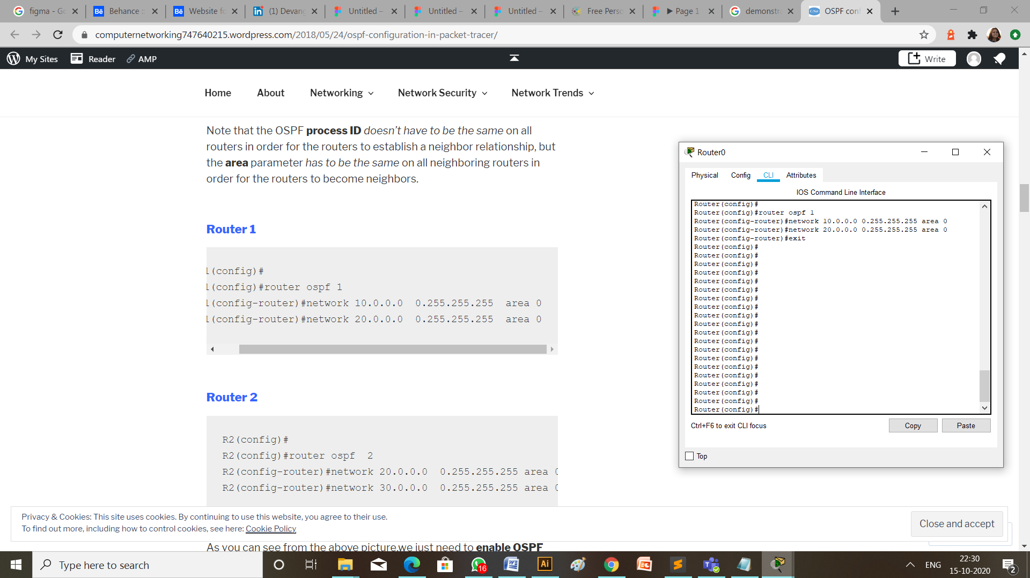

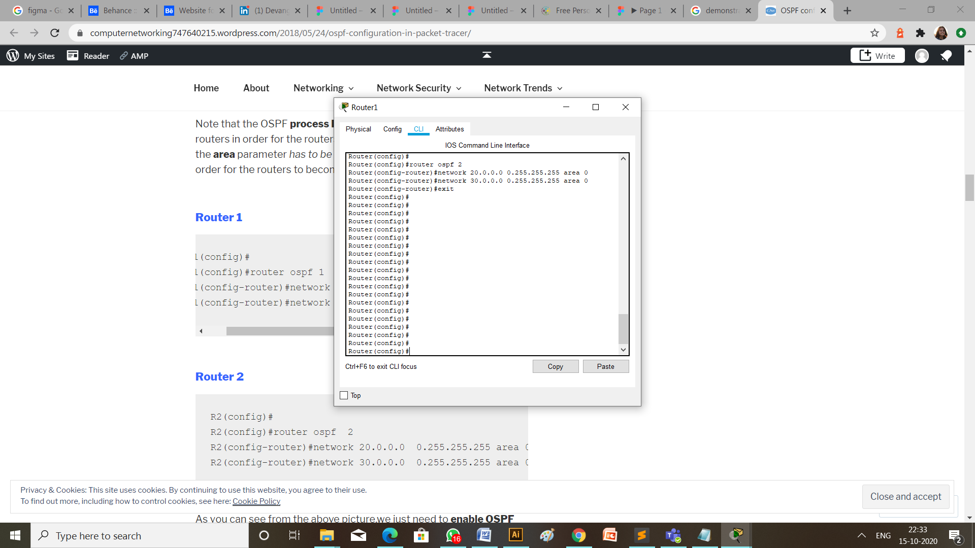

* Verify OSPF configuration.

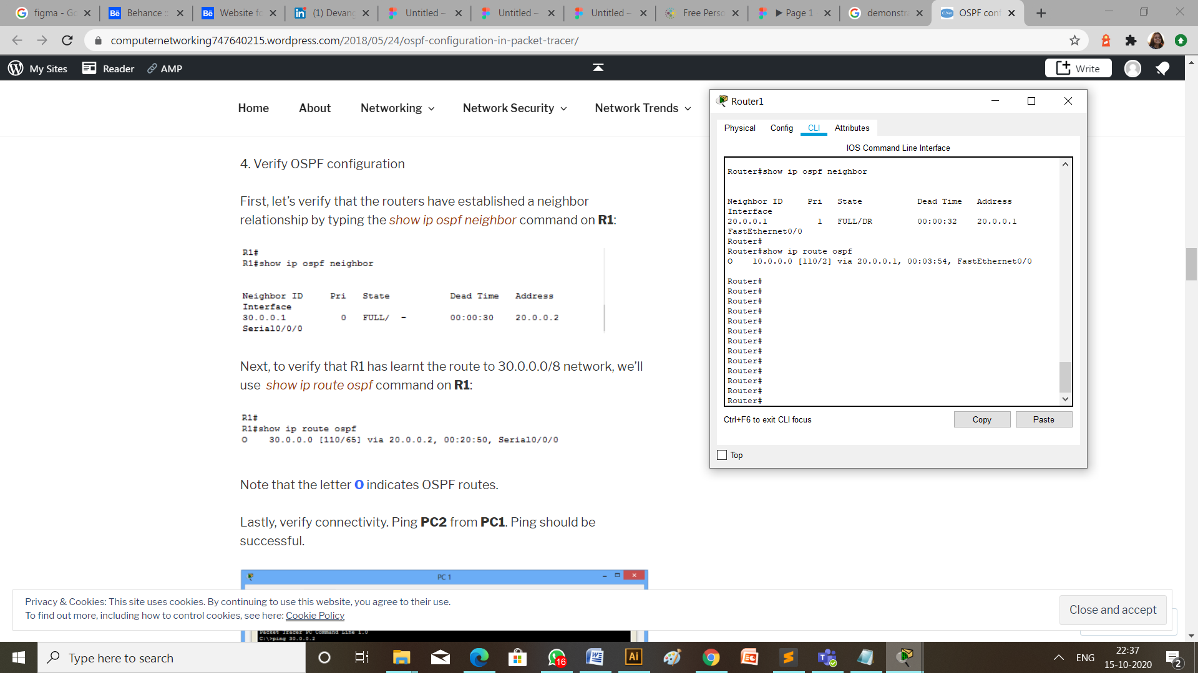

**Checking Network Topology:**

1. Message passing:

To check the connections are working properly or not drop one package on a Laptop 1 and receive it from the Laptop 0.



1. Using ping:

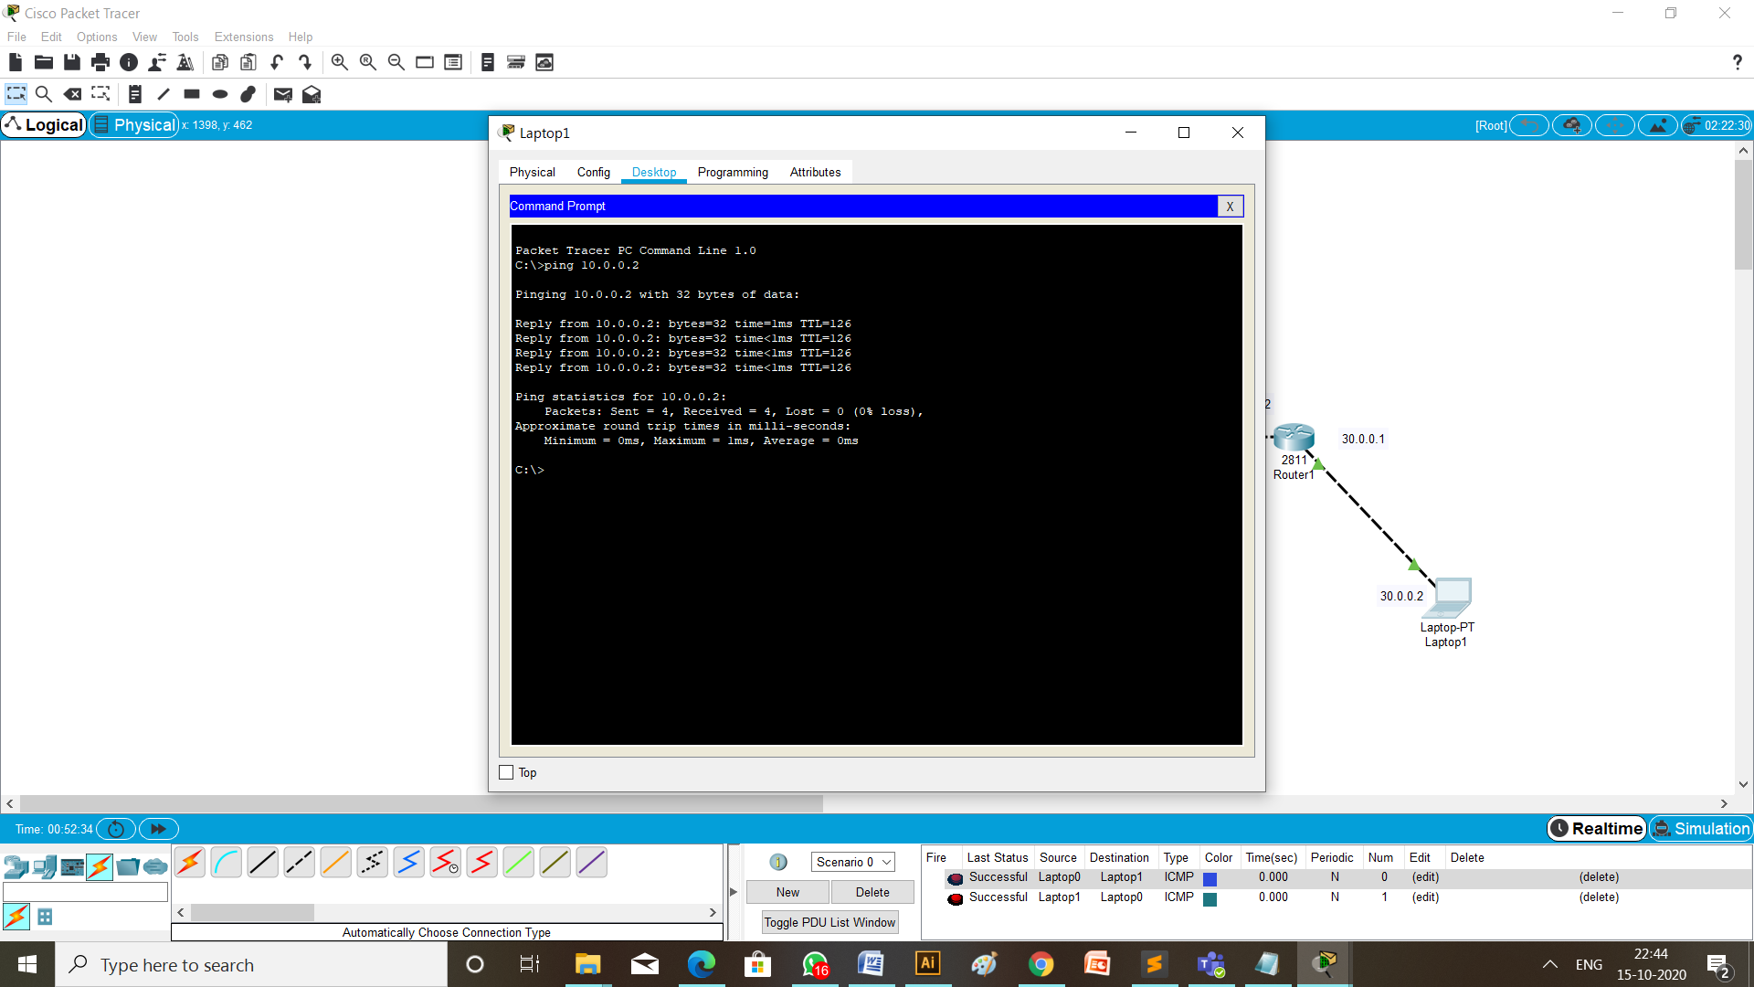Write a command ping 30.0.0.2 (ip address of the destination Laptop) from the command prompt of Laptop having ip address 10.0.0.2 (the source Laptop).

**Conclusion:**

Through this practical I learned about how to configure dynamic routing of routers using RIPv2 and OSPF protocol in different networks.

**Practical 5**

**Aim:** Demonstrate the EIGRP and BGP protocol configuration using cisco packet tracer.

**Theory:**

**BGP Protocol:**

* Border Gateway Protocol (BGP) is an Internet Engineering Task Force (IETF) standard, and the most scalable of all routing protocols.
* BGP is the routing protocol of the global Internet, as well as for Service Provider private networks.
* BGP has expanded upon its original purpose of carrying Internet reachability information, and can now carry routes for Multicast, IPv6, VPNs, and a variety of other data.
* Cisco supports all IETF BGP standards, as well as most or all Internet Drafts for BGP. In addition, Cisco is an active participant in the BGP working groups at the IETF and a frequent contributor of new BGP extensions.

**EIGRP Protocol:**

* Enhanced Interior Gateway Routing Protocol (EIGRP) is an interior gateway protocol suited for many different topologies and media.
* In a well-designed network, EIGRP scales well and provides extremely quick convergence times with minimal network traffic.
* Very low usage of network resources during normal operation; only hello packets are transmitted on a stable network
* When a change occurs, only routing table changes are propagated, not the entire routing table; this reduces the load the routing protocol itself places on the network
* Rapid convergence times for changes in the network topology (in some situations convergence can be almost instantaneous)
* EIGRP is an enhanced distance vector protocol, relying on the Diffused Update Algorithm (DUAL) to calculate the shortest path to a destination within a network.

**EIGRP protocol configuration:**

**Topology:**

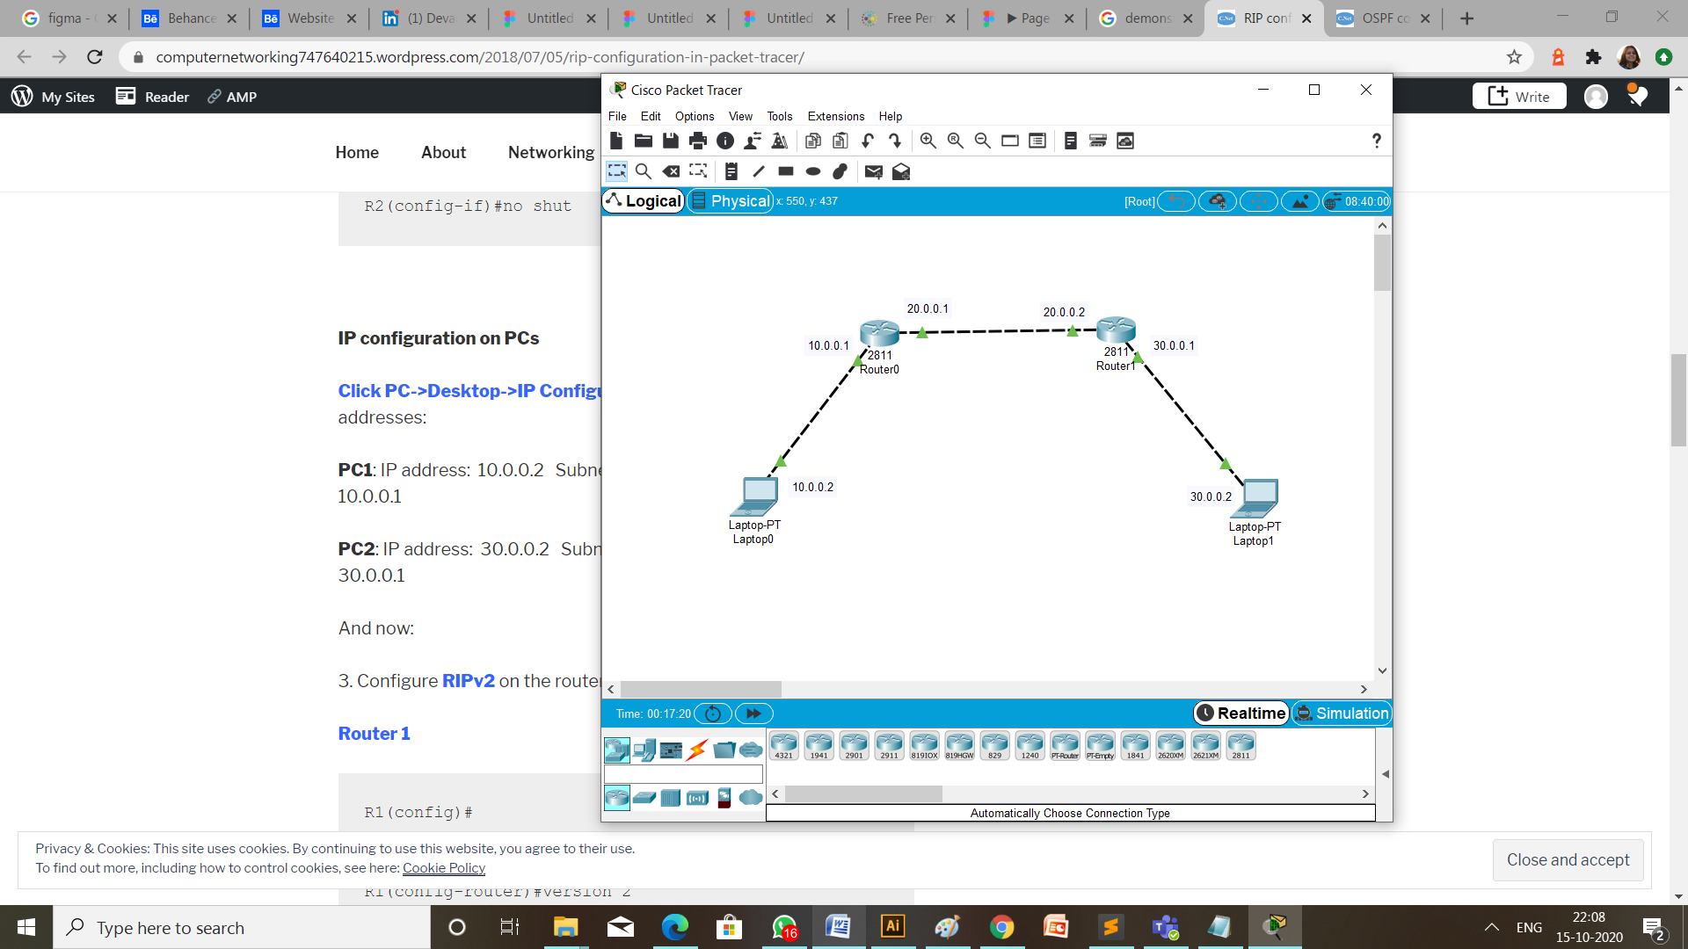

**Steps of Configurations:**

* First of all to create a topology, click on the device and drop on workplace and connect all the devices with the necessary cables.
* Then configure all the router using CLI and give the ip address as mention in the topology diagram.

1. Router 1: fa0/0 1.0.0.1

fa0/1 2.0.0.1

1. Router 2: fa0/0 2.0.0.2

fa0/1 3.0.0.1

* Provide ip address and default gateway to the laptops.
  1. Laptop 1: ip address is 1.0.0.2

default gateway is 1.0.0.1

* 1. Laptop 2: ip address is 3.0.0.2

default gateway is 3.0.0.1

* Configuration of EIGRP on router 0 and router 1 are respectively,

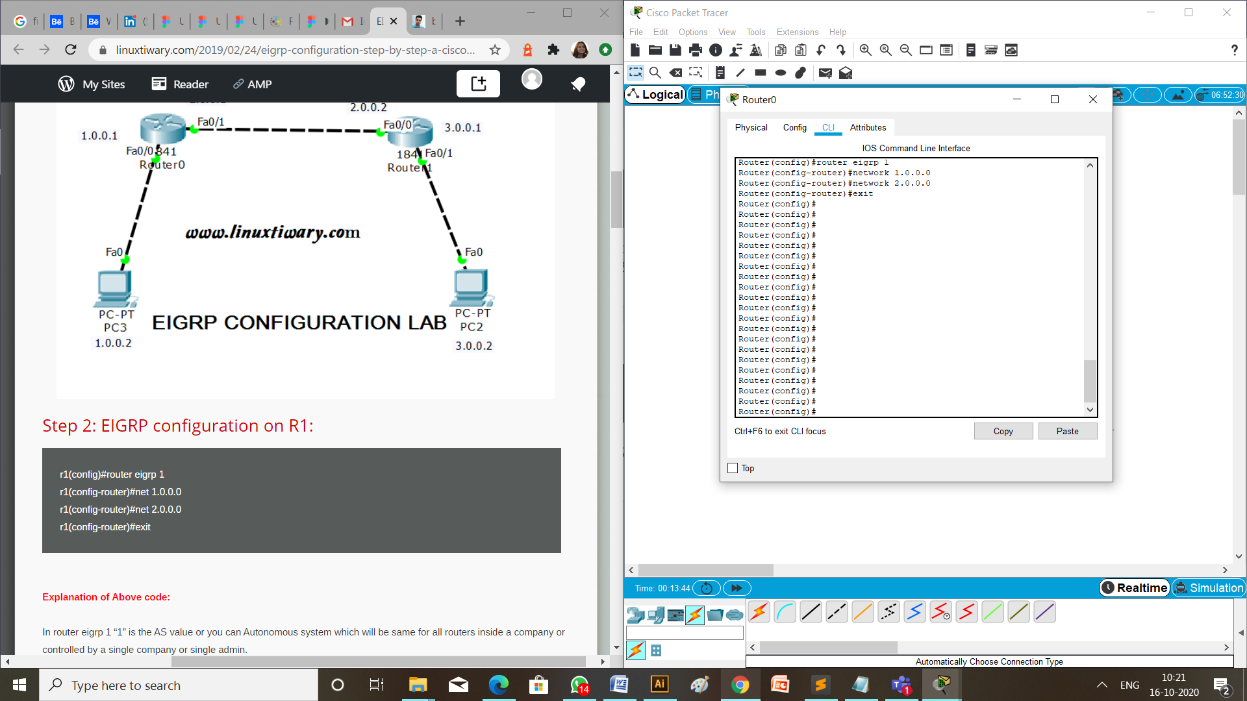

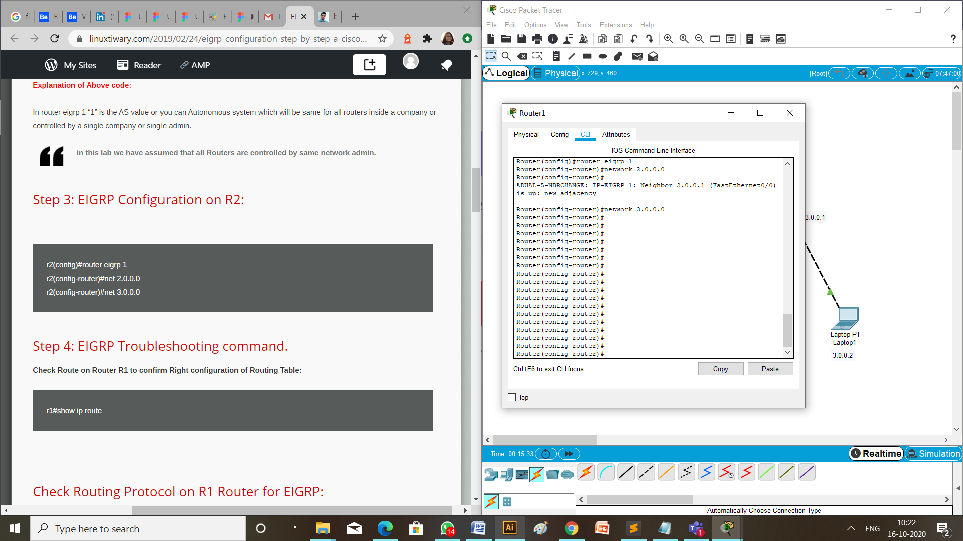

* Verify EIGRP configuration.

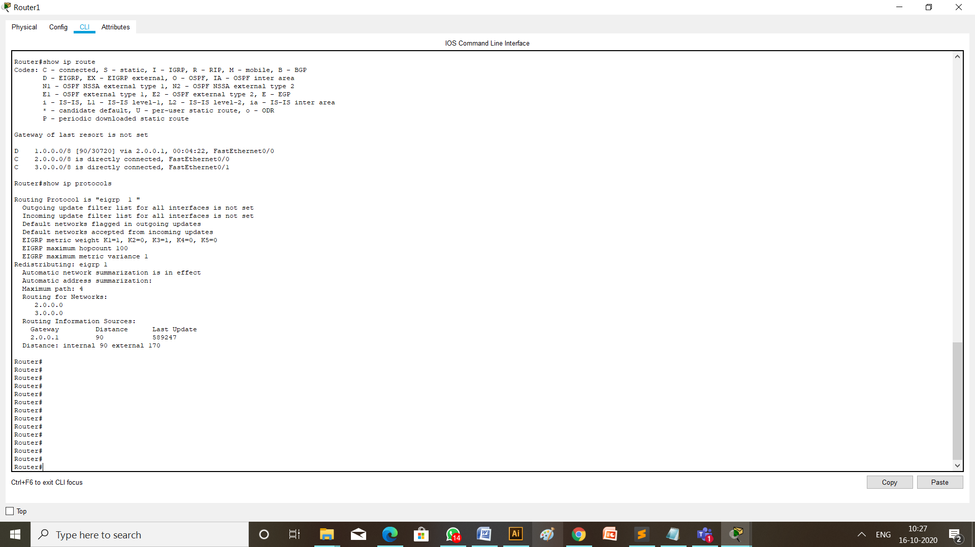

**Checking Network Topology:**

1. Message passing:

To check the connections are working properly or not drop one package on a Laptop 0 and receive it from the Laptop 1.

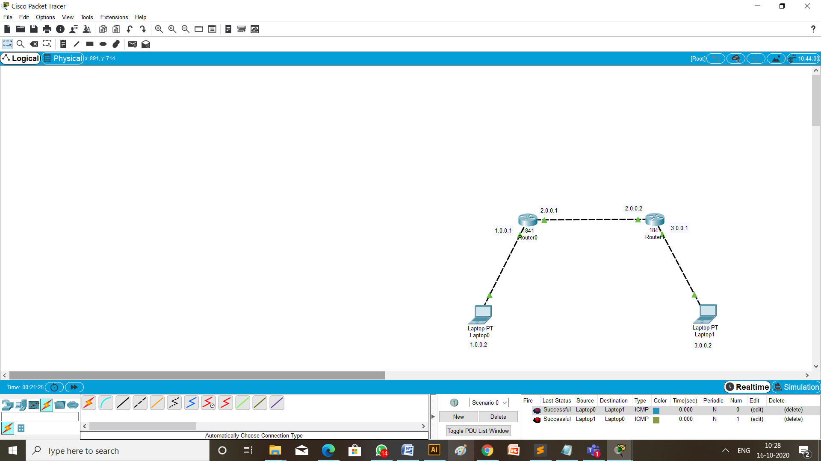

1. Using ping:

Write a command ping 1.0.0.2 (ip address of the destination Laptop) from the command prompt of Laptop having ip address 3.0.0.2 (the source Laptop).

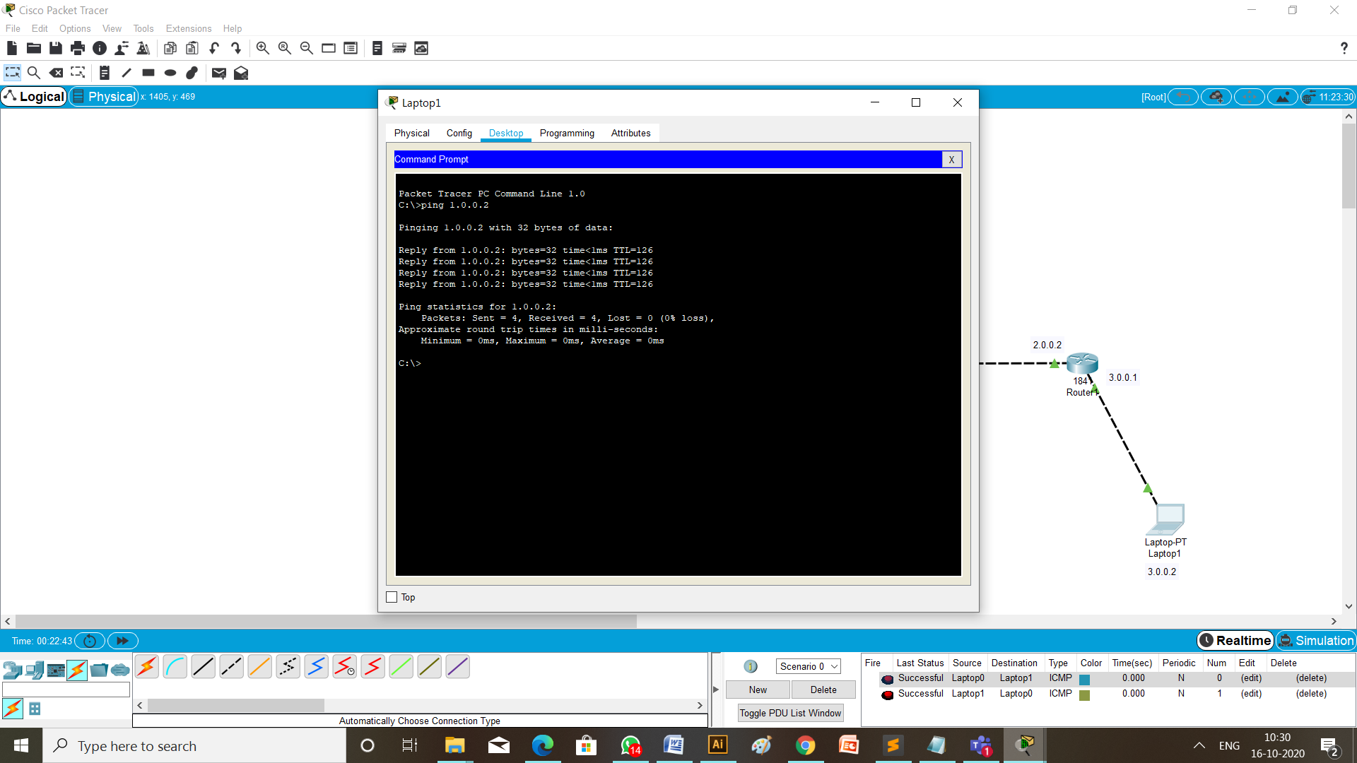

**BGP protocol configuration:**

**Topology:**

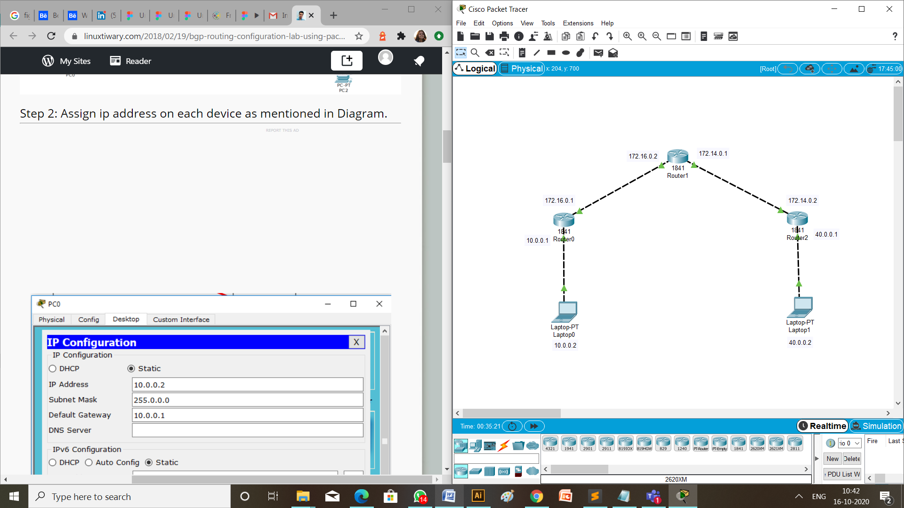

**Steps of Configurations:**

* First of all to create a topology, click on the device and drop on workplace and connect all the devices with the necessary cables.
* Then configure all the router using CLI and give the ip address as mention in the topology diagram.

1. Router 1: fa0/0 10.0.0.1

fa0/1 172.16.0.1

1. Router 2: fa0/0 172.16.0.2

fa0/1 172.14.0.1

1. Router 2: fa0/0 172.14.0.2

fa0/1 40.0.0.1

* Provide ip address and default gateway to the laptops.
  1. Laptop 1: ip address is 10.0.0.2

default gateway is 10.0.0.1

* 1. Laptop 2: ip address is 40.0.0.2

default gateway is 40.0.0.1

* Configuration of BGP on router 0, router 1 and router 2 are respectively,

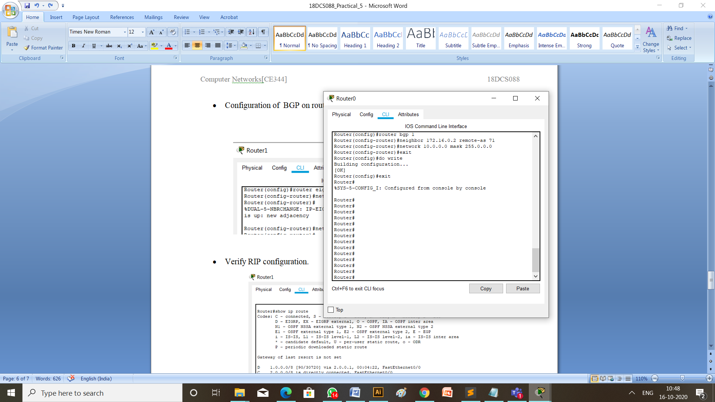

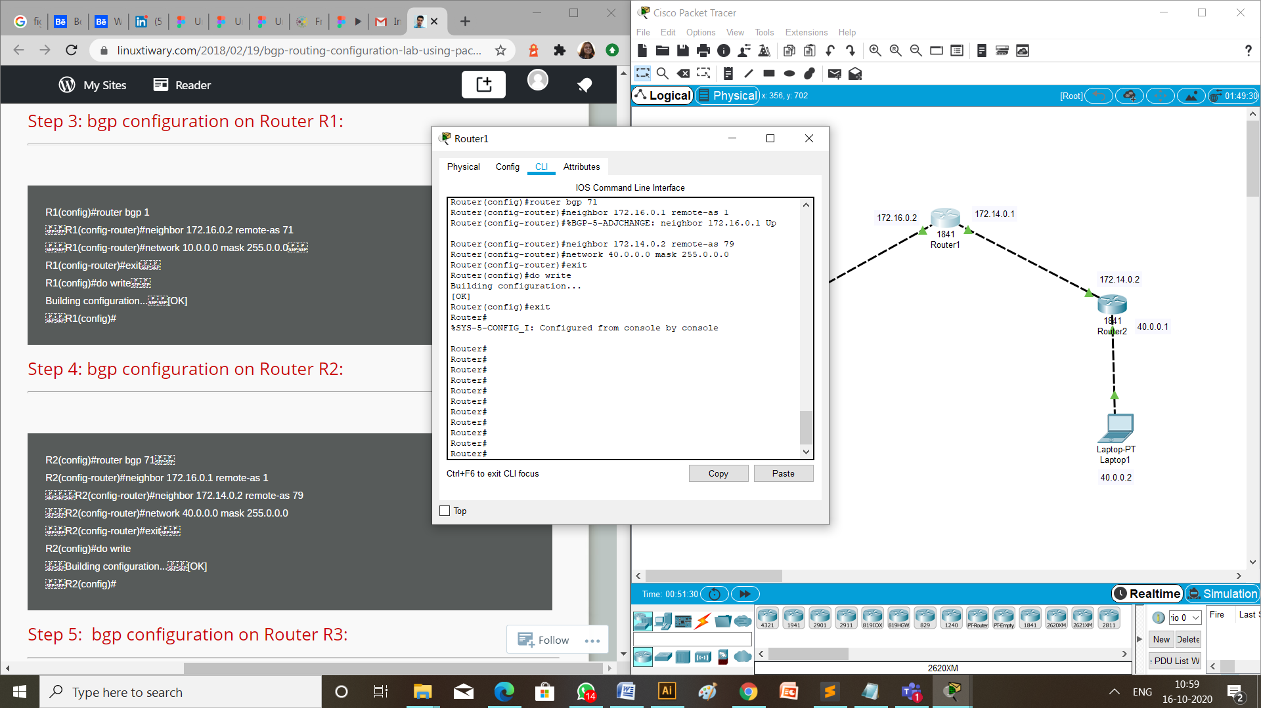

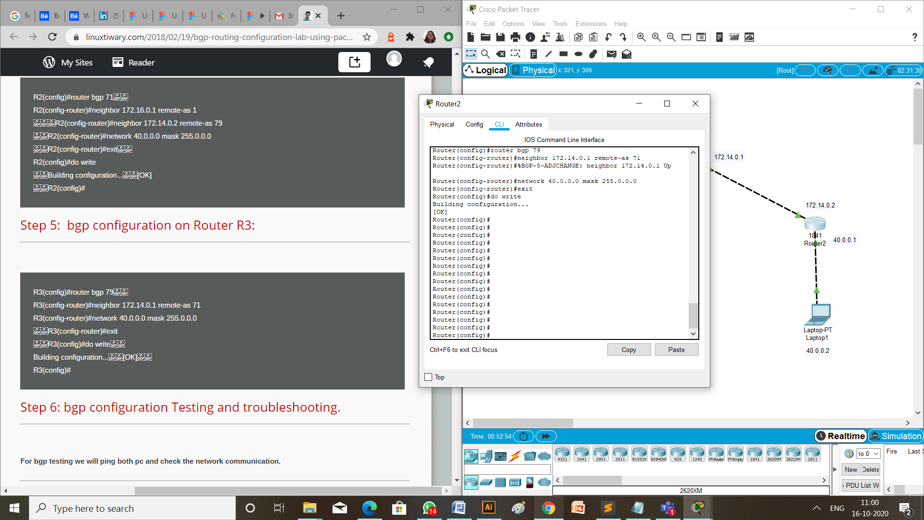

* Verify BGP configuration.

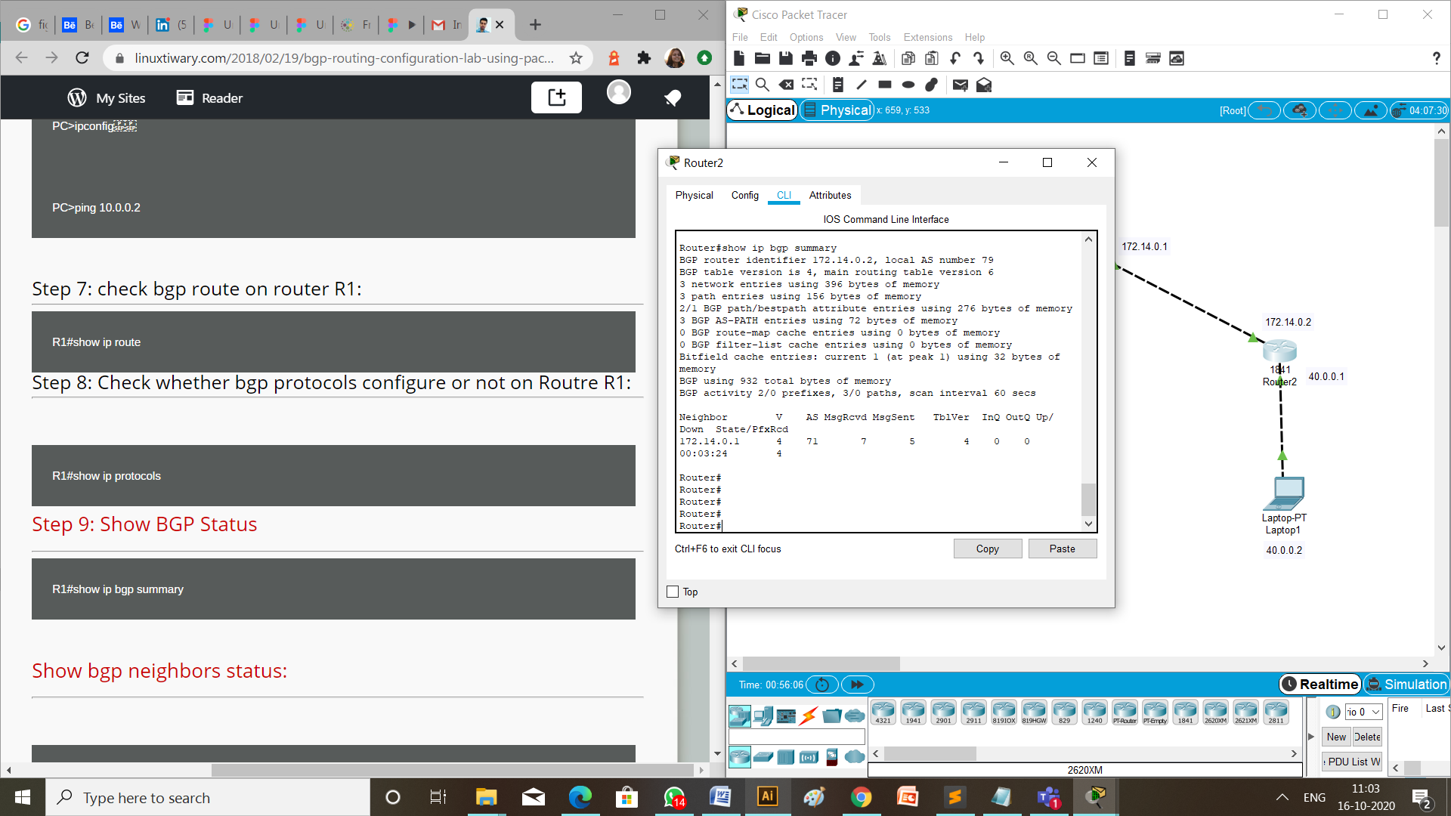

**Checking Network Topology:**

1. Message passing:

To check the connections are working properly or not drop one package on a Laptop 1 and receive it from the Laptop 0.

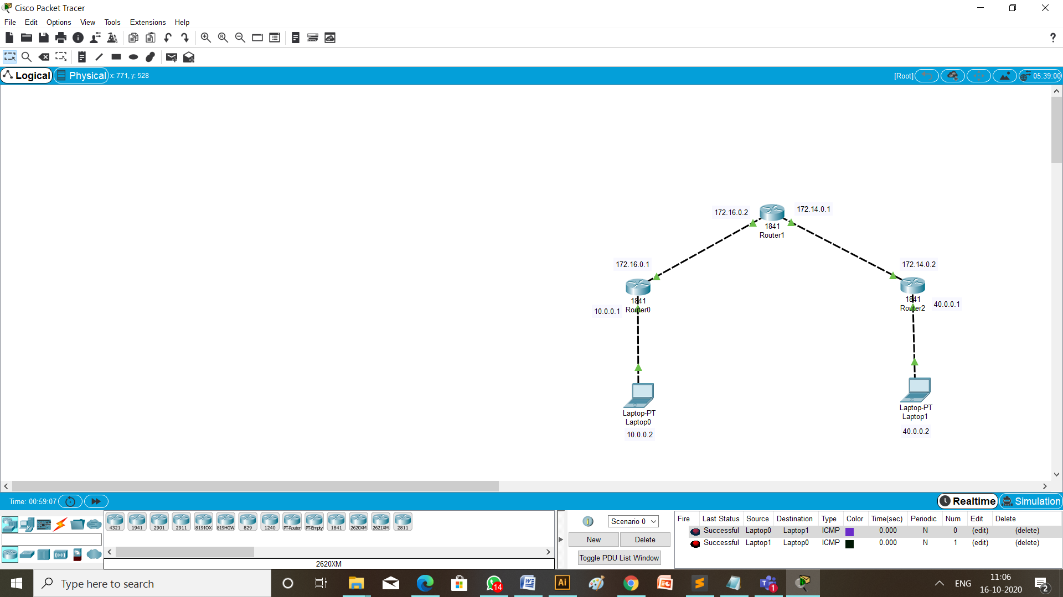

1. Using ping:

Write a command ping 40.0.0.2 (ip address of the destination Laptop) from the command prompt of Laptop having ip address 10.0.0.2 (the source Laptop).

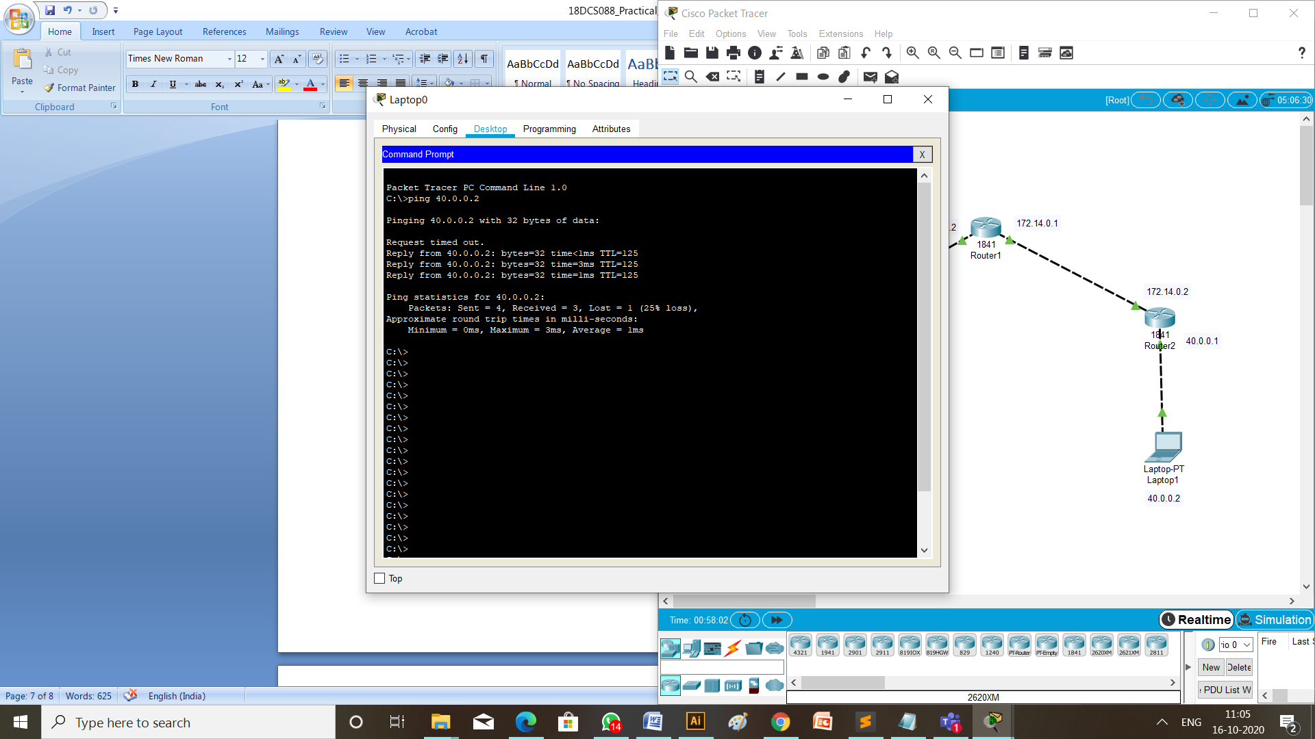

**Conclusion:**

Through this practical I learned about how to configure BGP and EIGRP protocols in different networks.

**Practical 6**

**Aim:** Demonstrate the static and dynamic configuration of NAT using cisco packet tracer

**Theory:**

* **NAT:**
  + What is Network Address Translation (NAT)?
    - NAT (Network Address Translation) is a process of changing the source and destination IP addresses and ports.
    - Address translation reduces the need for IPv4 public addresses and hides private network address ranges.
    - The process is usually done by routers or firewalls.
  + How does it work?
    - NAT allows a single device, such as a router, to act as an agent between the Internet (or public network) and a local network (or private network), which means that only a single unique IP address is required to represent an entire group of computers to anything outside their network.
  + There are three types of address translation.
    - Static NAT – translates one private IP address to a public one. The public IP address is always the same.
    - Dynamic NAT – private IP addresses are mapped to the pool of public IP addresses.
    - Port Address Translation (PAT)– one public IP address is used for all internal devices, but a different port is assigned to each private IP address. Also known as NAT Overload.

**Static configuration of NAT:**

**Topology:**

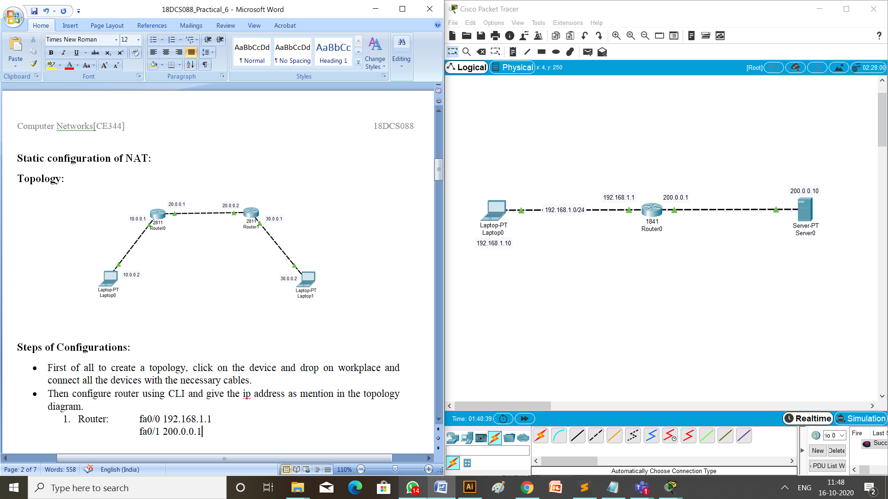

**Steps of Configurations:**

* First of all to create a topology, click on the device and drop on workplace and connect all the devices with the necessary cables.
* Then configure router using CLI and give the ip address as mention in the topology diagram.

1. Router: fa0/0 192.168.1.1

fa0/1 200.0.0.1

* Provide ip address and default gateway to the laptop.

1. Laptop: ip address is 192.168.1.10

default gateway is 200.0.0.1

* Provide ip address and default gateway to the server.

1. Server: ip address is 200.0.0.10

default gateway is 200.0.0.1

* Configuration of Static NAT on router 0,

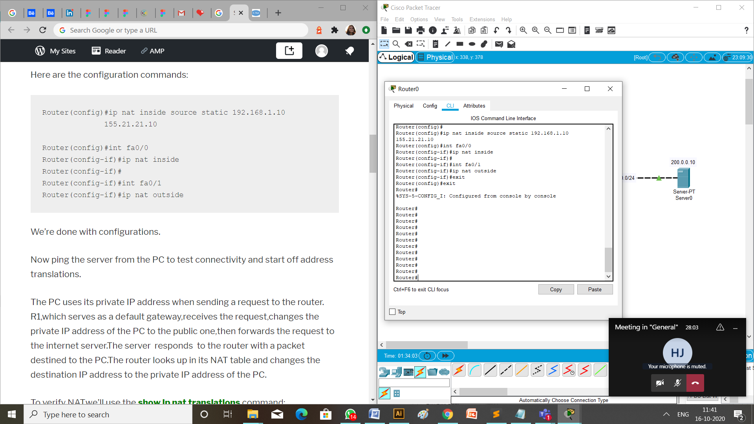

* Verify Static NAT configuration.

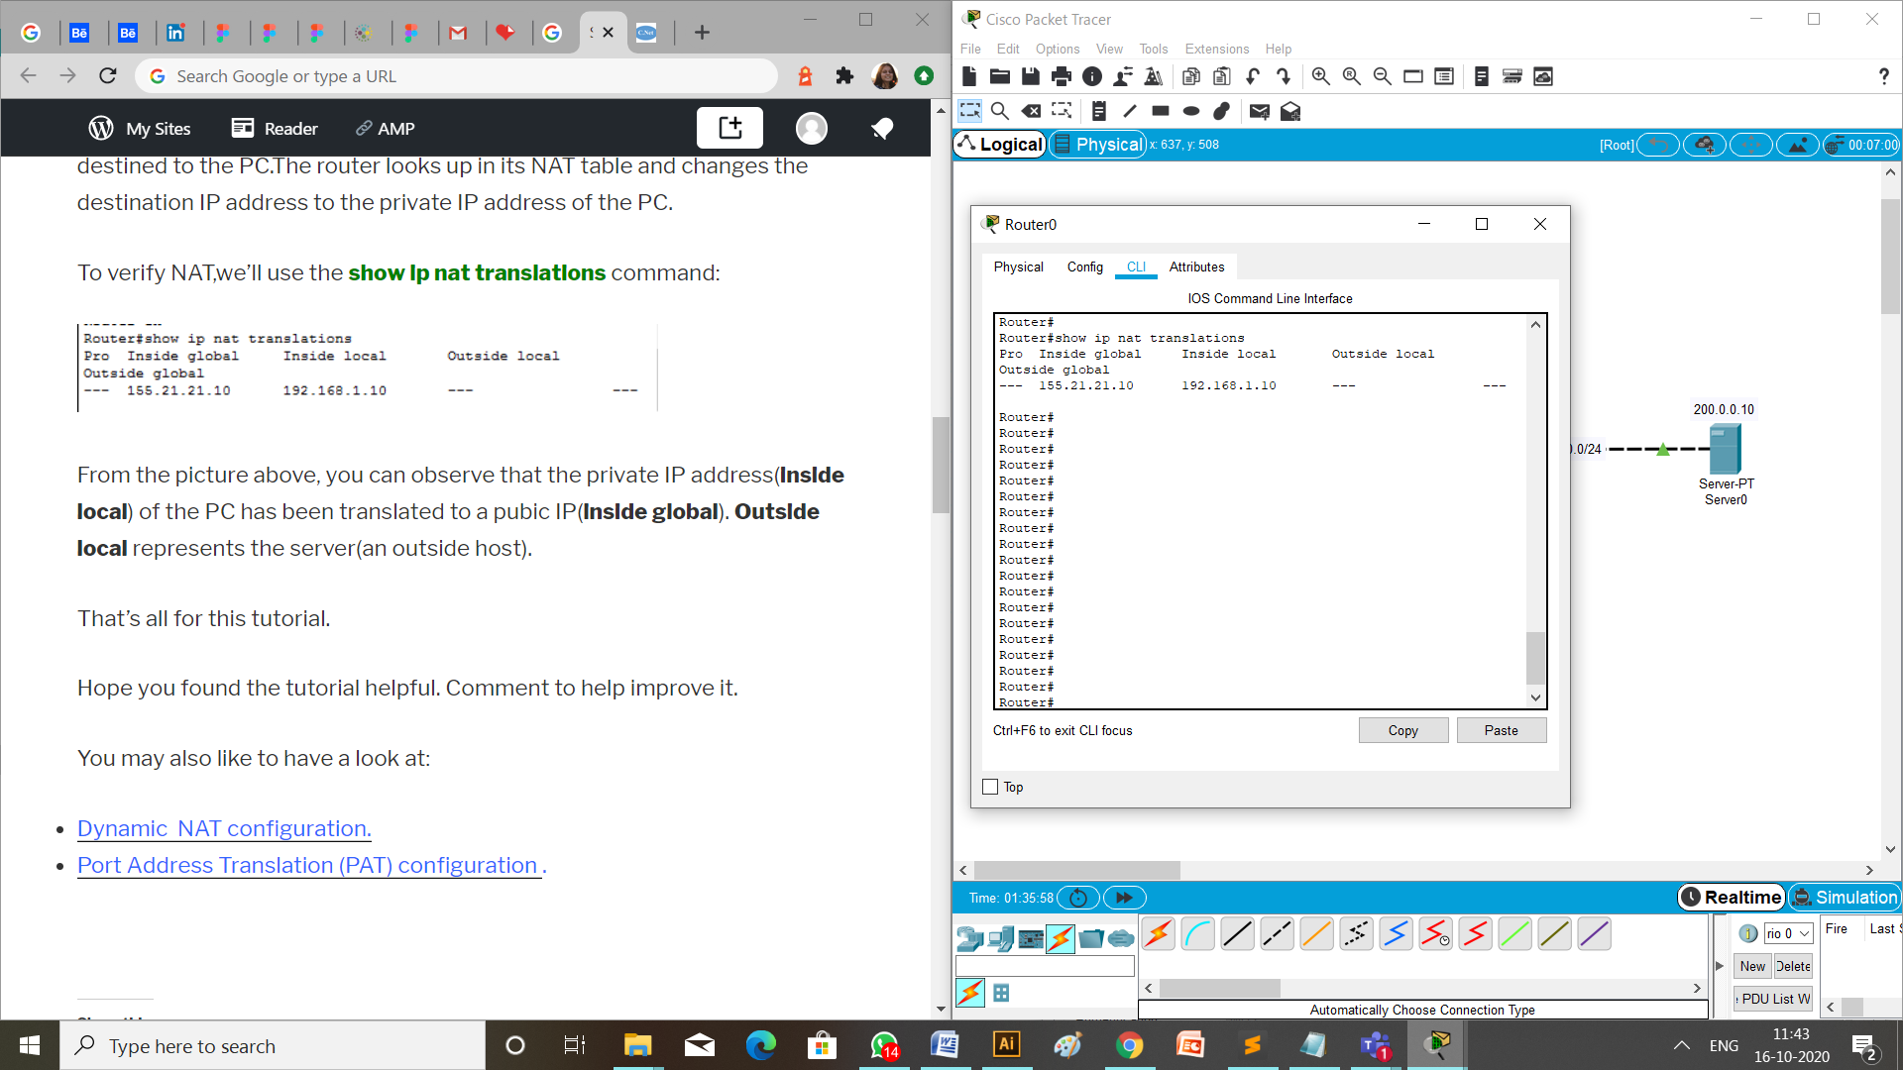

**Checking Network Topology:**

1. Message passing:

To check the connections are working properly or not drop one package on a Laptop and receive it from the Server.

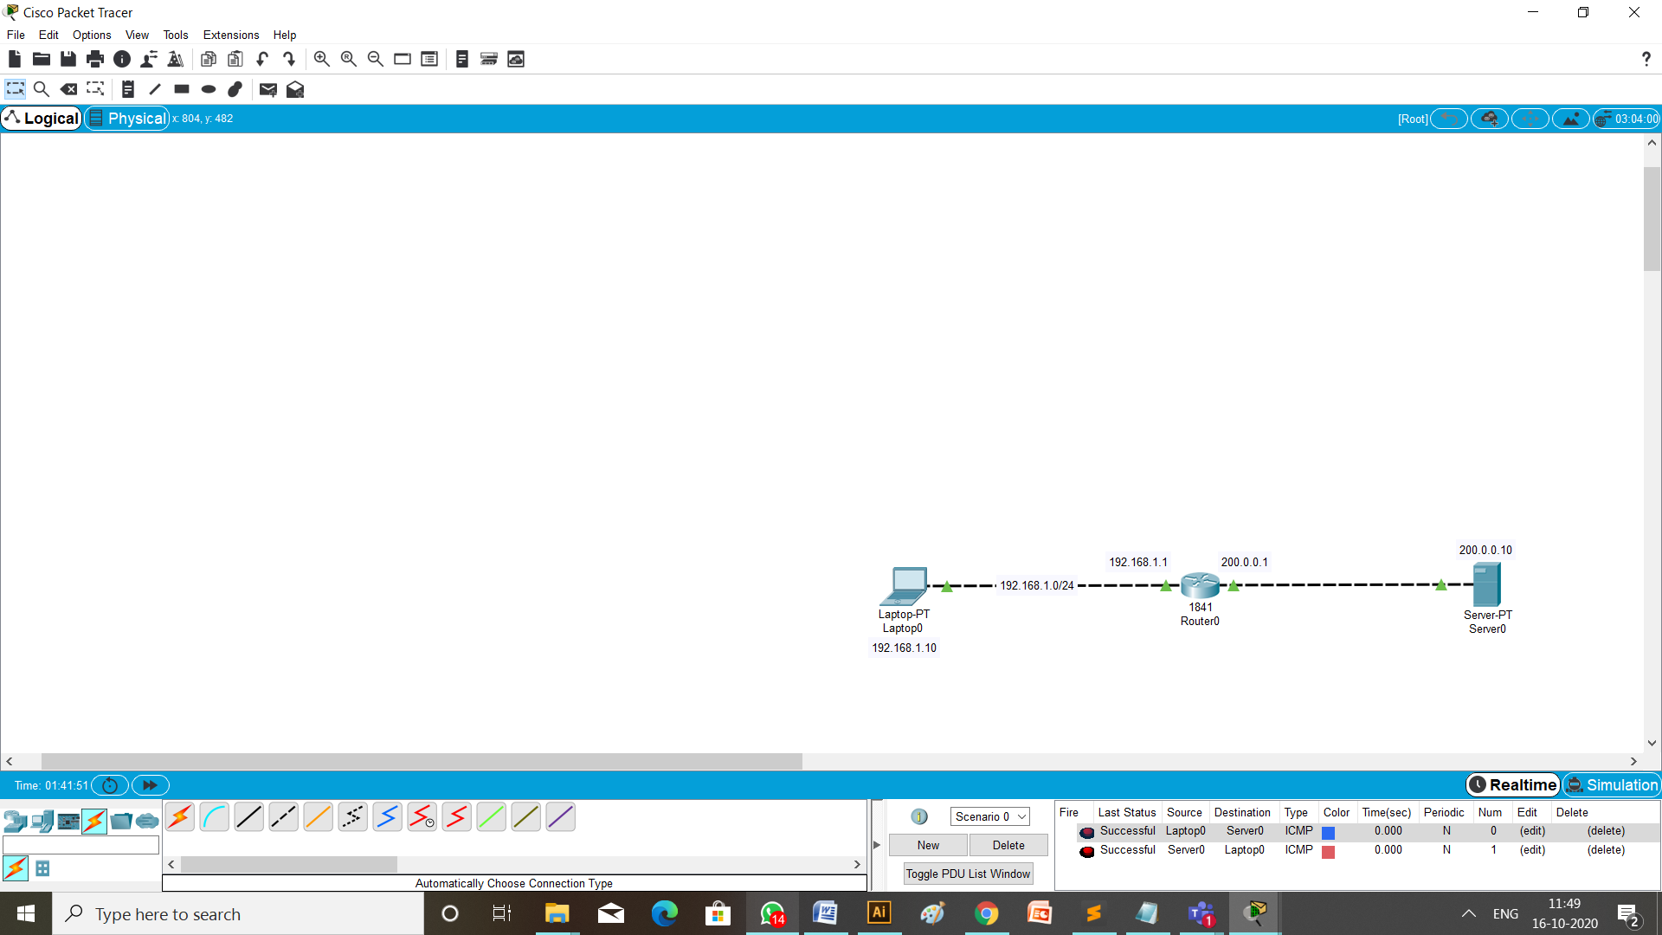

1. Using ping:

Write a command ping 200.0.0.10 (ip address of the Server) from the command prompt of Laptop having ip address 192.168.1.10 (the source Laptop).

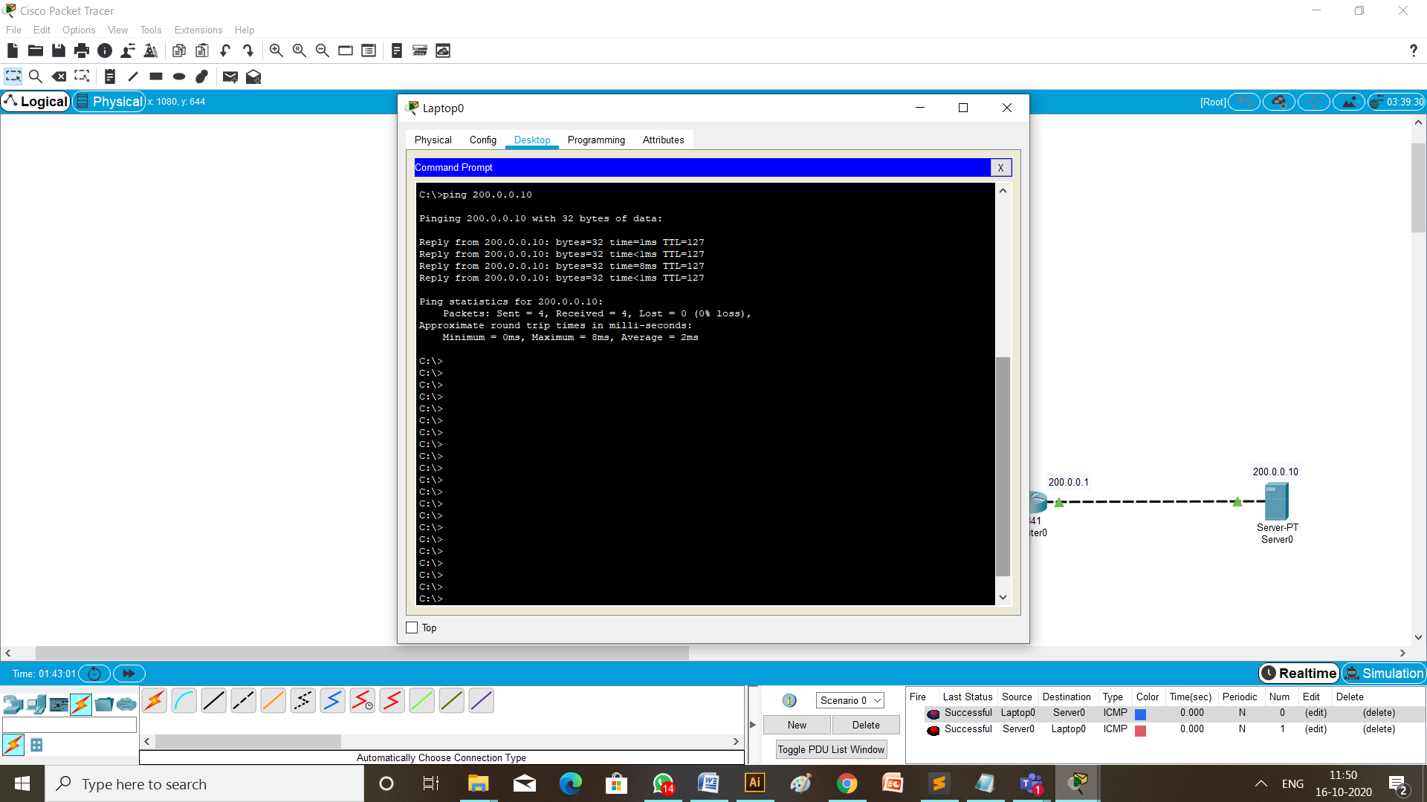

**Dynamic configuration of NAT:**

**Topology:**

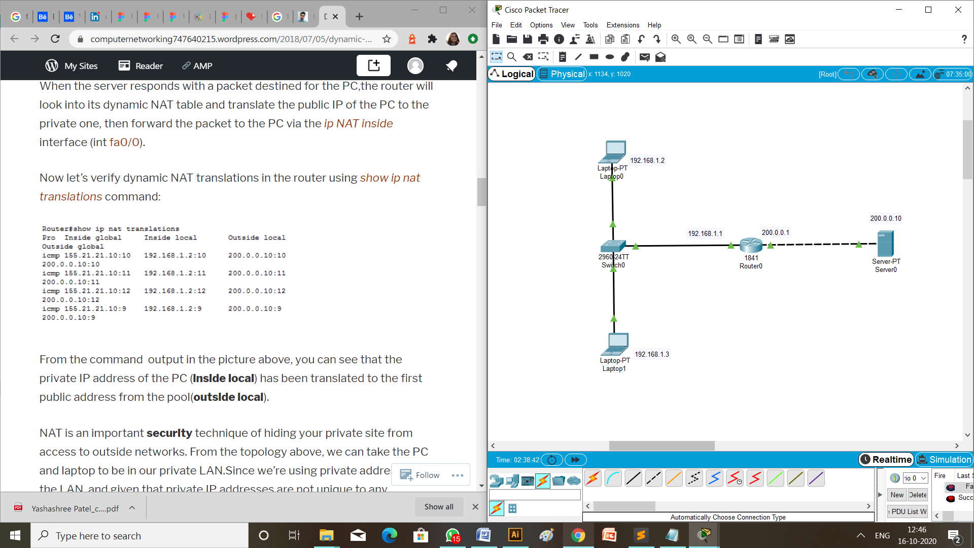

**Steps of Configurations:**

* First of all to create a topology, click on the device and drop on workplace and connect all the devices with the necessary cables.
* Then configure router using CLI and give the ip address as mention in the topology diagram.

1. Router: fa0/0 192.168.1.1

fa0/1 200.0.0.1

* Provide ip address and default gateway to the laptop.
  1. Laptop 1: ip address is 192.168.1.2

default gateway is 200.0.0.1

* 1. Laptop 2: ip address is 192.168.1.3

default gateway is 200.0.0.1

* Provide ip address and default gateway to the server.
  1. Server: ip address is 200.0.0.10

default gateway is 200.0.0.1

* Configuration of Dynamic NAT on router 0,

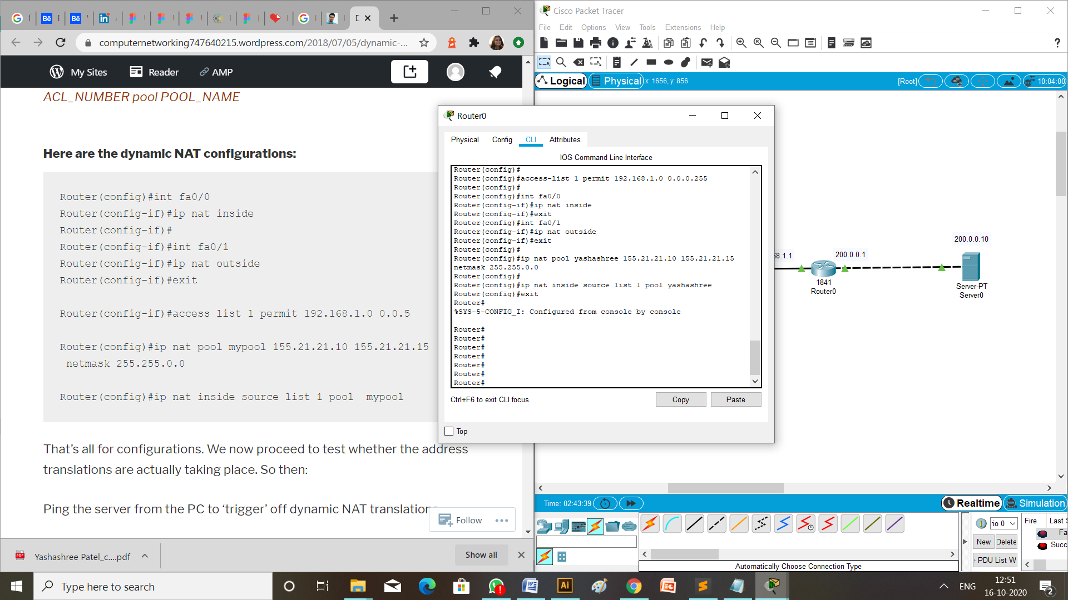

* Verify Dynamic NAT configuration.

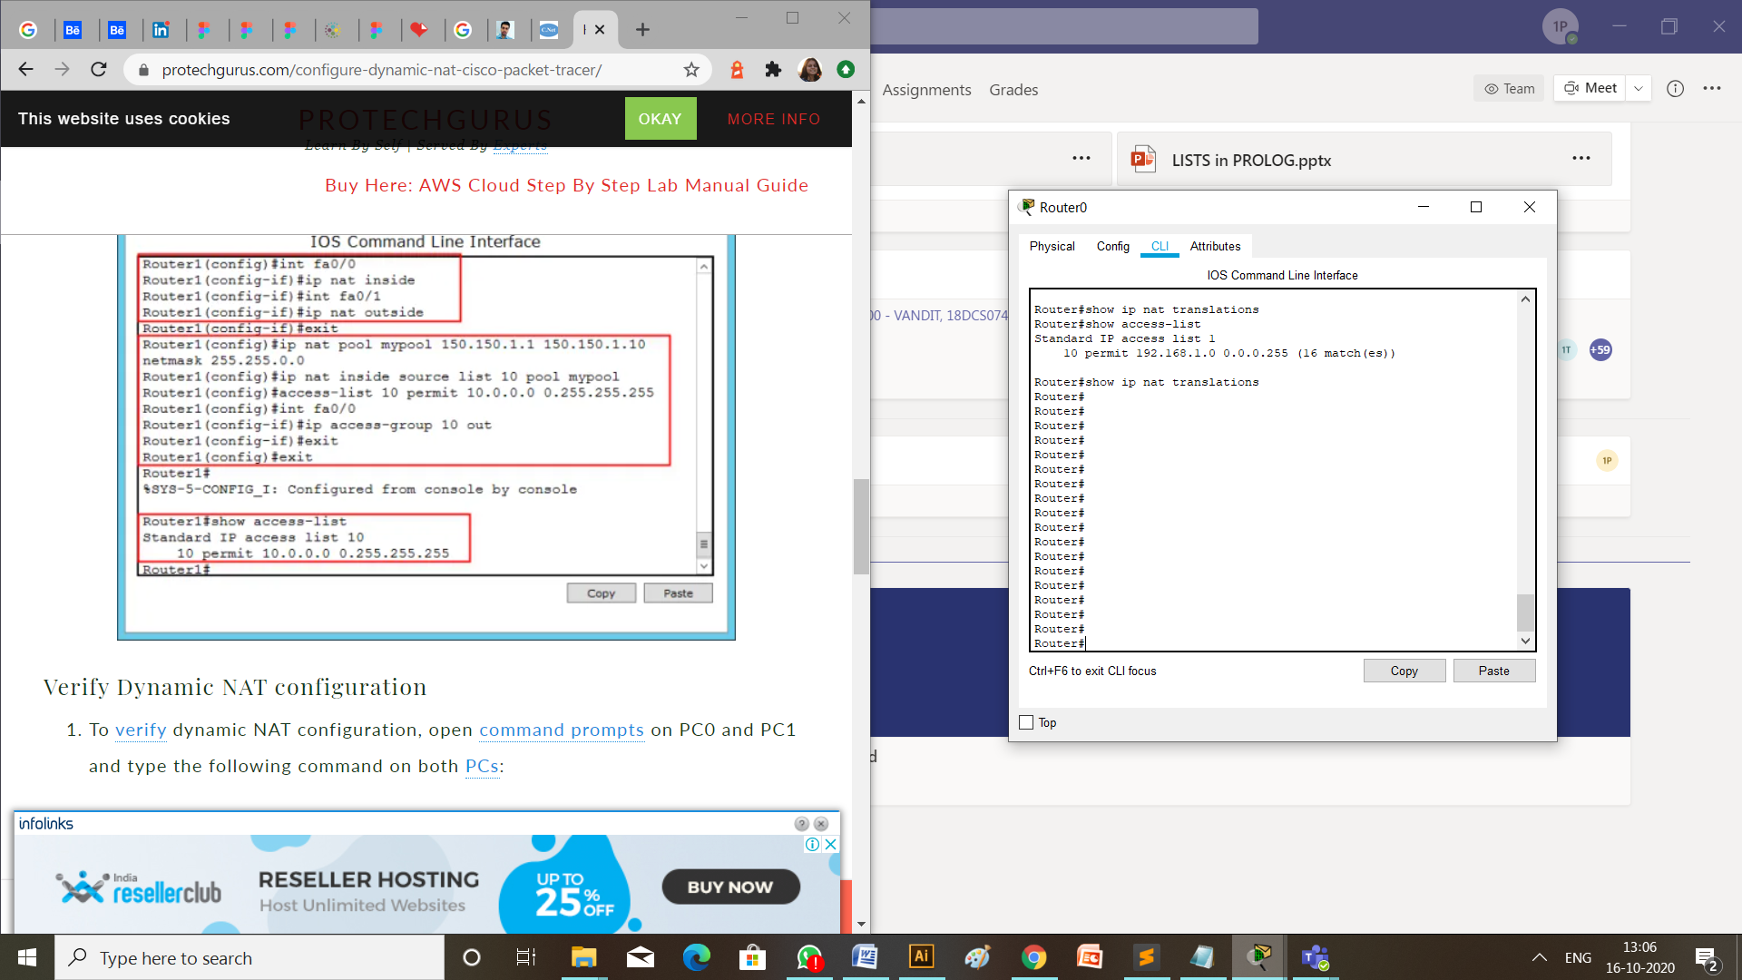

**Checking Network Topology:**

1. Message passing:

To check the connections are working properly or not drop the packets from laptop to server.

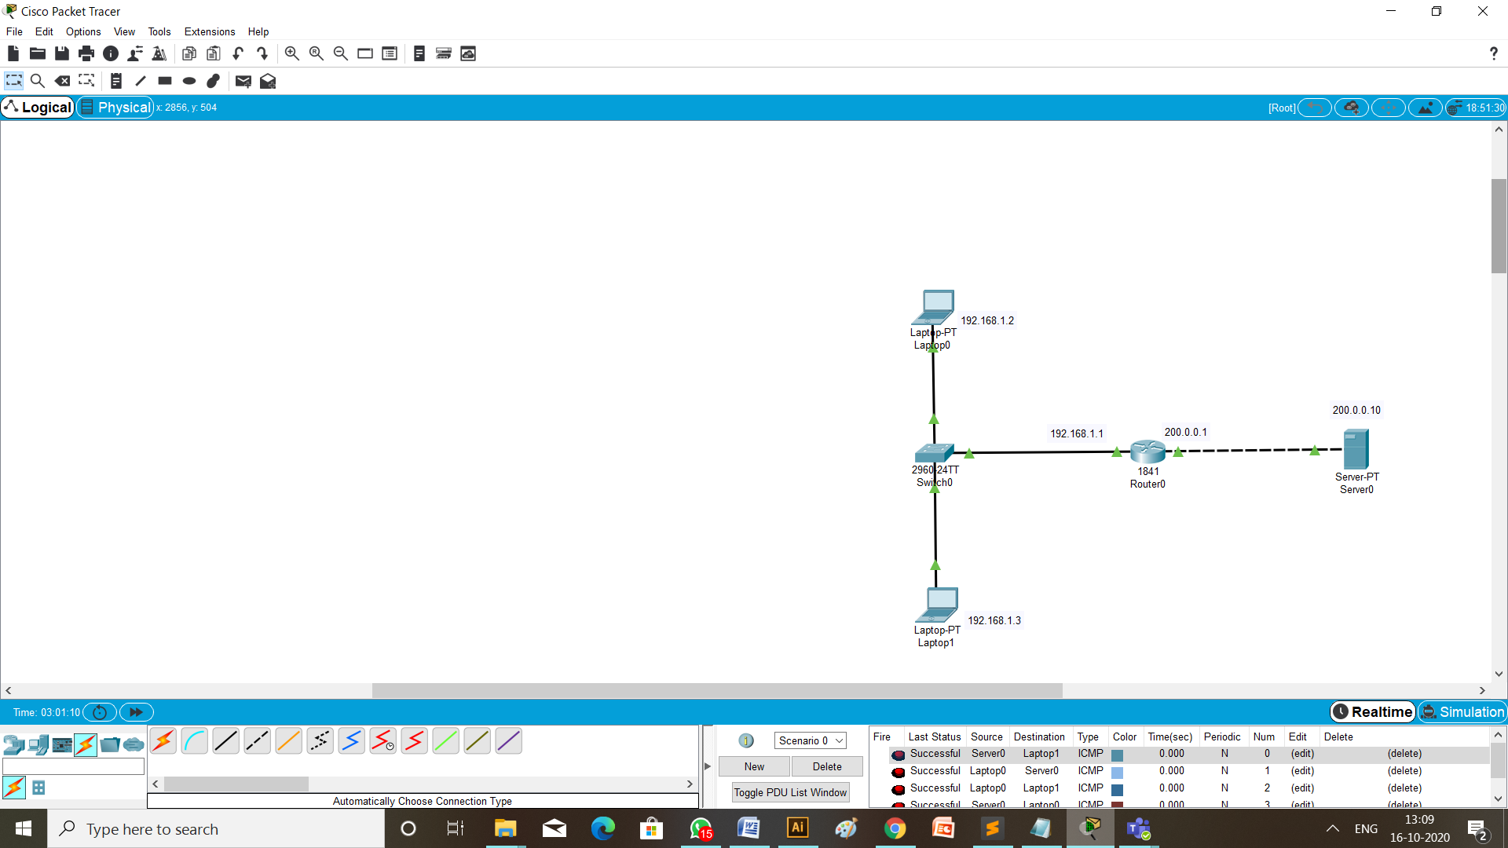

1. Using ping:

Write a command ping 200.0.0.10 (ip address of the Server) from the command prompt of Laptop having ip address 192.168.1.2 (the source Laptop 0).

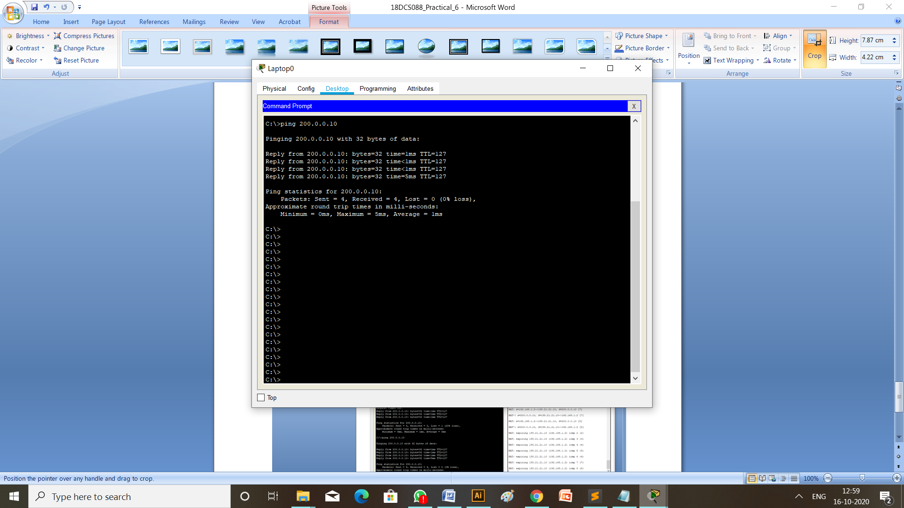

Just when ping run *<debug ip nat>* command on router:

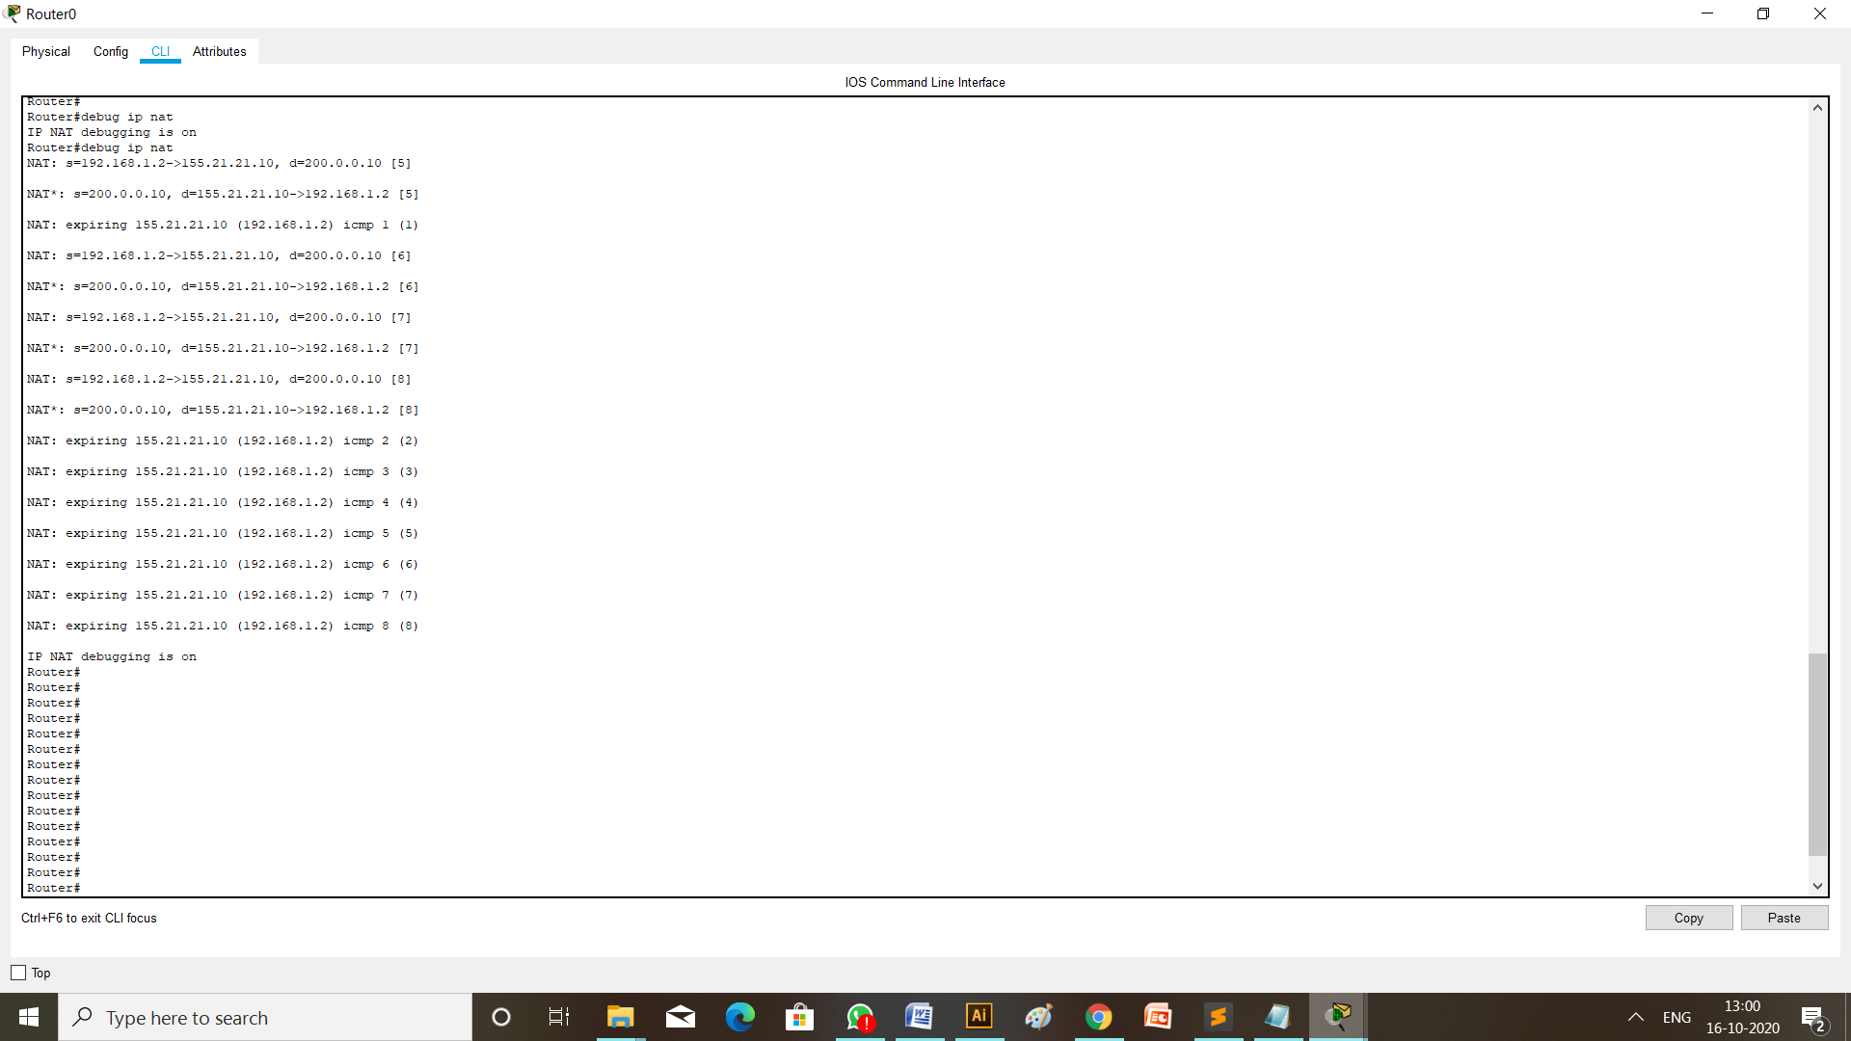

**Conclusion:**

Through this practical I learned about how to configure Dynamic and Static NAT (Network Address Translation) in cisco packet tracer.